MPUMALANGA PROVINCIAL GOVERNMENT



DELIVERY AGREEMENT FOR OUTCOME 2
A LONG AND HEALTHY LIFE FOR ALL SOUTH AFRICANS
DATE: 08 DECEMBER 2010

LEAD DEPARTMENT: DEPARTMENT OF HEALTH



TABLE OF CONTENTS

1. INTRODUCTION 3
2. BROAD STATEMENT OF HEALTH SECTOR CHALLENGES 4
3. CHALLENGES RELATING TO SPECIFIC OUTPUT AREAS 5
4. IDENTIFICATION FOR DELIVERY PARTNERS 16
5. IMPLEMENTATION PLAN 18
6. SIGNATORIES 23

1. INTRODUCTION

The Service Delivery Agreement is a charter that reflects the commitment of key sectoral and intersectoral partners linked to the delivery of identified outputs as they relate to a particular sector of government. The Government has agreed on 12 key outcomes as the key indicators for its programme of action for the period 2010 – 2014. Each outcome area is linked to a number of outputs that inform the priority implementation activities that will have to be undertaken over the given timeframe to achieve the outcomes associated with a particular output.
For the health sector, the priority is improving the health status of the entire population and to contribute to Government’s vision of “A Long and Healthy Life for All South Africans”. To accomplish this vision government has identified four strategic outputs which the health sector must achieve. These are:
- Output 1: Increasing Life Expectancy
- Output 2: Decreasing Maternal and Child mortality
- Output 3: Combating HIV and AIDS and decreasing the burden of diseases from Tuberculosis
- Output 4: Strengthening Health System Effectiveness

Linked to these outputs are indicators and targets. Major targets include the following:
- Life expectancy must increase from the current at 43.6 years for males and 45.3 years for females (Statistics SA 2009) to 58 years for males and 60 years for females by 2014.
- South Africa’s Maternal Mortality Ratio (MMR) must decrease from the estimated 137 per 100,000 to 117 (or less) per 100,000 live births by 2014.
- Child mortality rates must decrease from the current 69 deaths per 1,000 live births to 45 deaths (or less) per 1,000 live births by 2014.
- The TB cure rate must improve from 64.5% in 2008 to 85% by 2014
- 80% of eligible people living with HIV and AIDS must access antiretroviral treatment.
- New HIV infections must be reduced by 50%.

Re-engineering the health system to one that is based on a primary healthcare (PHC) approach, with more emphasis on promotive and preventive (instead of curative) healthcare will underlie all interventions needed to achieve the above-mentioned outputs. Tangible improvements in the effectiveness of the health system must be attained and corroborated by empirical evidence that clearly links to the four output areas.

2. BROAD STATEMENT OF HEALTH SECTOR CHALLENGES

Mpumalanga Province like elsewhere in South Africa currently faces a quadruple Burden of Disease (BoD) consisting of HIV and AIDS and TB; High Maternal and Child Mortality; Non-Communicable Diseases and; Violence and Injuries.
Despite spending 8.7% of South Africa’s GDP on health, and spending more on health than any other African country, the South African health care system has been characterized as fragmented and inequitable due to the huge disparities that exist between the public and private health sectors with regards to the availability of financial and human resources, accessibility and delivery of health services. A decision was taken in 1994 to implement a Primary Health Care Approach as the backbone of the healthcare system. Despite this, the service delivery structure still leans heavily towards a curative approach high-cost care with no adherence to any referral system, which implies that many patients are seen at seen at an inappropriate level, usually by specialists and in hospitals, and this contributes to cost escalation.
The inequity in the health system is exacerbated by the fact that access to health care is unequal with the majority of the population relying on a public health care system that has a disproportionately lower amount of financial and human resources at its disposal relative to the private sector. For instance, the per capita spend in the public sector is estimated at R1, 600 whilst in the private sector it is R9, 800 in nominal terms. Furthermore, the distribution of key health professionals between the two sectors is also skewed. In the public sector there are about 4,200 patients to a general doctor compared to 243 patients to a general doctor in the private sector. This, coupled with the poor funding of the public health sector, has significantly contributed to the poor health status of the national population, including poor infant and maternal mortality indicators.

While access in terms of reach has been achieved, more still needs to be done in terms of improving quality of care, human resources management, infrastructure and making services more available to all South Africans to ensure better health outcomes.

3. CHALLENGES RELATING TO SPECIFIC OUTPUT AREAS
- Increasing Life Expectancy
Life expectancy is affected by communicable diseases such as HIV, TB, malaria, respiratory infections and diarrheal diseases; increased maternal and child mortality; non-communicable diseases such as diabetes and cardio vascular diseases; as well as trauma related injuries. Malaria has contributed to reduction in life expectancy; constitutes a major barrier to social and economic development in the region and is mainly transmitted along the border areas of South Africa. Malaria is currently well controlled in Mpumalanga Province.
Globalisation has contributed to increased international travel and trade, and the emergence and reemergence of international communicable disease threats. These threats call for epidemic preparedness and the effective implementation of the International Health Regulations (IHRs). In terms of the IHRs, South Africa is required to develop minimum core public health capacities, and to develop, strengthen and maintain these by July 2012.
South Africa’s life expectancy is depicted as follows:
Figure 1: Life expectancy at birth by sex and province: 2006

- Figure1 shows that life expectancy at birth was higher for Western Cape and Gauteng for both males and females compared to other provinces in 2006
- Mpumalanga Province is associated with a low life expectancy at birth for both sexes in 2006
- However, the lowest life expectancy at birth is linked to Kwa-Zulu Natal in 2006.

- Decreasing Maternal and Child Mortality
The maternal mortality in Mpumalanga Province like the rest of provinces South Africa is much higher than that of the countries of similar socio-economic development. The vision is to reduce the maternal and child mortality through the implementation of Primary Health Care and a functional referral system to responsive support system of hospitals.
The National Committee on the Confidential Enquiry into Maternal Deaths (NCCEMD) report has identified the following as the main causes of maternal deaths:
    - Women at special risk of maternal death
    - Health seeking behaviour of pregnant women
    - Problems at the primary health care level
    - Problems at the secondary care level
    - Problems at all levels of care
It is therefore recommended that in order to decrease maternal and child mortality the following should be undertaken:
    - Referral hospitals for hypertension
    - Management of Pneumonia and AIDS
    - Recognition of obstructed labour
    - Management of labour in women with previous caesarean sections
    - Availability of blood
    - Termination of Pregnancy services
    - Multidisciplinary care
    - Anaesthetic services
    - Prophylactic antibiotics
    - Family planning service
For more details please refer to NCCEMD report.
- Combating HIV and AIDS and decreasing the burden of diseases from Tuberculosis
South Africa has the highest burden of HIV with an estimated 5.62 million people or 17.2% of the population infected. This is evidenced by the HIV prevalence rates among antenatal cases (ANC) as depicted in the following table:
Table 1: Provincial HIV Prevalence of Adults 15 – 49, 2008 and 2009

The following figures below gives a provincial picture in terms of HIV prevalence trends by province, age group and by geography. Figure 2a shows the provincial trend since 1991 which rose sharply from this period until 1998 where it started to mature though at high prevalence. It has been showing spikes from 1998 till 2009. The provincial HIV prevalence for 2009 is 34.7%.

Figure 2b shows prevalence by geography, that is, district HIV prevalence. HIV prevalence for Gert Sibande has decline from forties in thirties. The most concerning district is Nkangala which has in number of years has been showing steady increase with its HIV prevalence.
Figure 2c shows prevalence by age group. The age group mostly affected is the age group between is 25 – 39 years. The similar picture is seen in case of TB cases by age group as indicated in Figure 2d. The two figures are mirror image of each other showing that the economic productive age groups are mostly affected by these two conditions
Figure 2a: Provincial HIV Prevalence of Adults 15 – 49, 1991 - 2009
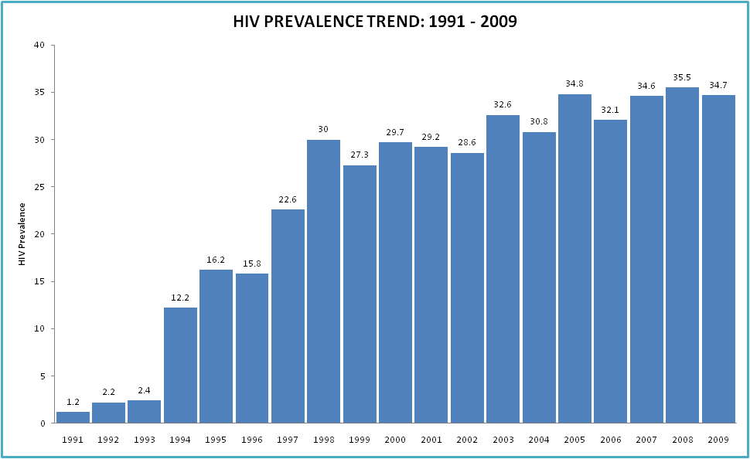
Figure 2b: Provincial HIV Prevalence of Adults 15 – 49 by District, 2006 - 2009
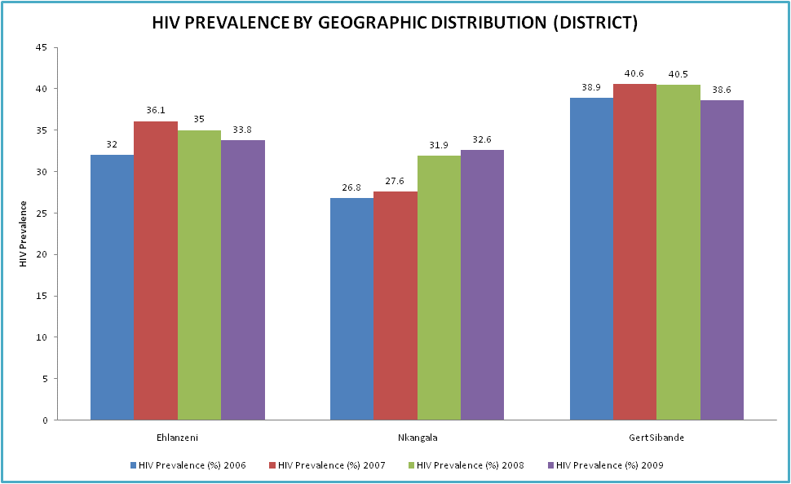

Figure 2c: Provincial HIV Prevalence by Age Group, 2006 - 2009
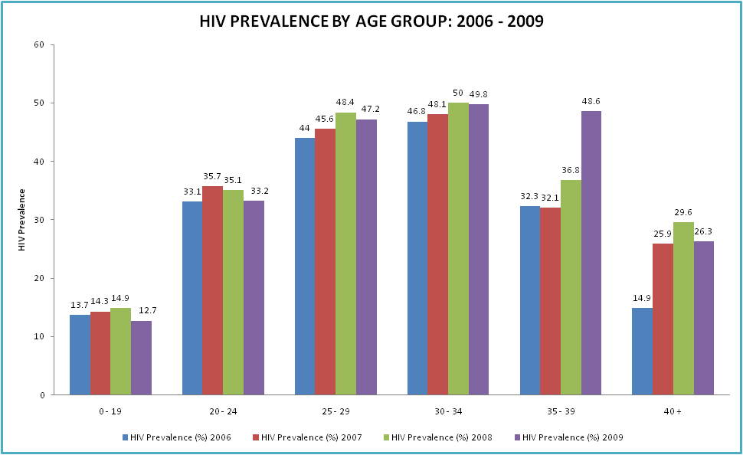
HIV Prevalence
Versus
TB Case by Age Group

Figure 2d: TB Cases by Age Group
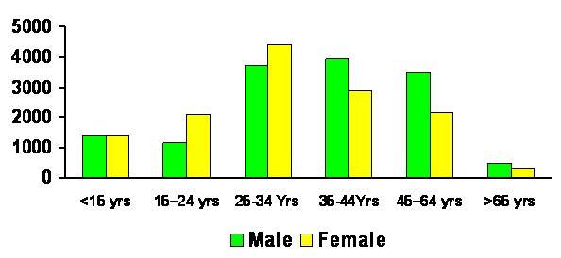
Tuberculosis is both a medical condition and a social problem and is linked to poverty related conditions. Problems of overcrowding and poor social conditions as well as environmental factors are contributory factors to its increased burden. It is important that the human settlement environmental affairs department join forces with health to address social determinants of health.
Action Plan
The HIV and AIDS Counseling and Testing (HCT) Campaign was launched in April 2010 by Minister of Health. The Provincial HCT Campaign was launched in Gert Sibande District due to its high HIV Prevalence. The core of the strategies to effectively combat these diseases is encompassed in the HCT Campaign whose primary focus is to scale up the integrated prevention strategy based on behavioural change, use of barrier methods, provision of medical male circumcision, scale up syndrome management of STI and the early prophylaxes Prevention of Mother-To-Child Transmission.

The HCT campaign is also aimed at making people know their status early by massively scaling up provider initiated HCT services in public and private health facilities, to reach people in their homes, work place and public spaces with messages that demonstrate the benefits of preventions and early access to treatment through providing HCT services at community level in homes, work place and public space to provide an opportunity of every South Africa to know their status so that they can take responsibility to prevent new infection and take steps. In order to achieve this effectively, the Department of Health will work closely with social partners to promote and facilitate open dialogue among communities, civil society and social partners to address the social, cultural and political barriers to reduce stigma, address gender issues that put women at risk and address community practices that turns a blind eye to violence, neglect and practices that make worse individual vulnerability to risk of new.

The Department will be launching medical male circumcision (MMC) in December 2010. The following two figures 3a and 3b indicate that male circumcision could assist in reducing HIV transmission. The figures indicate that where male circumcision is widely practiced, that is, more than 80% male circumcised, the chances of contracting or transmitting HIV is less.
Figure 3a: Advantages of performing Male Circumcision
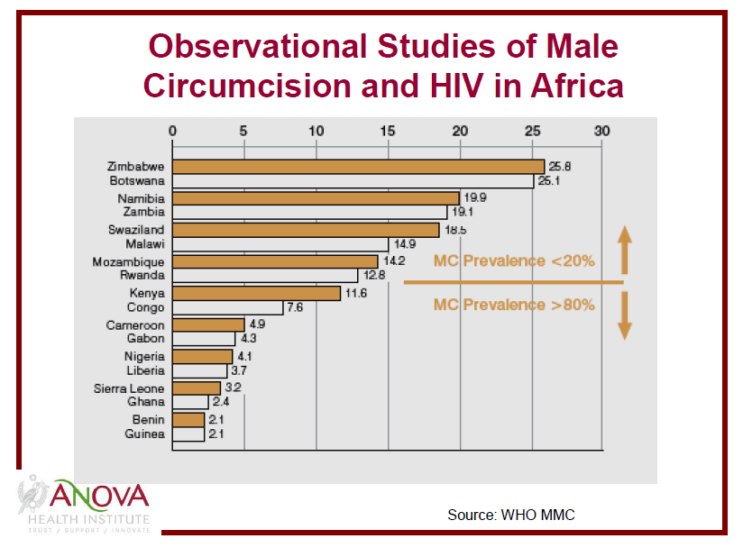
Figure 3a: Advantages of performing Male Circumcision

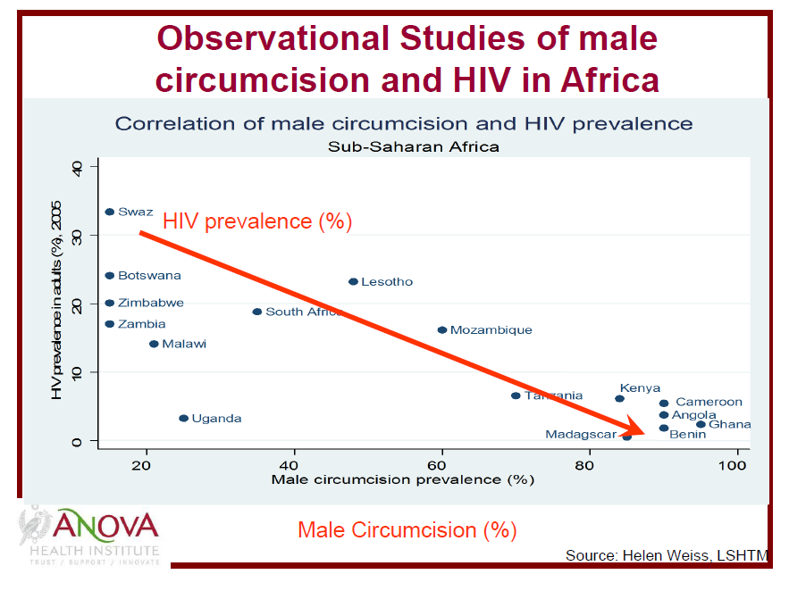
- Strengthening of Health Systems Effectiveness

A healthy life is the product of a mix of a functional and effective health system based on the use of cost-effective interventions that are rendered at an appropriate level of the health system coupled with the existence of reliable and equitable access to decent housing, clean water, sanitation, nutrition and education (i.e. social determinants of health) which are all products of a number of stakeholders including interdepartmental collaboration. The primary health care approach has been the underlying philosophy of our health system for the past 15 years. Yet the health system remains focused largely on curative care, rather than on the promotion of health and prevention of illness.

The following health system challenges are experienced

- Inadequate resources for establishment of Sub districts with management structures to enhance decentralization
- Poor PHC Infrastructure
- Difficulty in recruitment and retention of skilled professionals
- Lack of a Tertiary Hospital
- Disparity in salary levels as compared to the neighbouring provinces
- Shortage of Specialists

All in all the Department has managed to achieve the following in order to strengthen health system effectiveness:
- Governance structures have been established in 25/33 hospitals.
- 273/282 PHC facilities have functional Clinic Committees 198 Not Profit Organizations are funded to provide Community Based Health Services.
- Supported by other NGOs in the delivery of PHC.
Core Standards
Staff Attitude
Infection Control
Cleanliness
Waiting Time
Drug Supply
Patient Safety
- Developed Finance and Human Resource policy
- Developed an HR Plan
- Filled critical management posts
- Recruitment and Retention Strategy developed and implemented
- Skill audit for the employees at all levels
- Staff training and development
- Adherence to quality core standards
- Revitalization and upgrading of infrastructure
- Service Transformation Plan developed and implemented
- Approved Business Case for the establishment of Tertiary hospital linked to the envisaged university

A Turn Around Strategy has been adopted to reposition the department and ensure that:

- Performance targets outlined in the Annual Performance Plan and National 10 points plan are achieved
- Batho Pele Principles are applied
- Leadership Management competencies are exercised at all levels
- Integration of services at all levels
- District Health System approach is implemented

For further strengthen the health system effectiveness the Department will embark on carrying out the followings:
- Finalize Provincialization Process: currently only 27/65 local municipality clinics have been incorporated.
- Strengthen Partnerships with all stakeholders to accelerate service delivery.
- Review current policy on delegations to management to speed up service delivery
- Establishment of Provincial and District Health Councils
- Develop a PHC Model by March 2011
- Improve on Information Management
- Strengthen Monitoring and Evaluation at all levels

4. IDENTIFICATION FOR DELIVERY PARTNERS

The improvement of the health status of all South Africans is a responsibility that cut across a number of sectors, both internal and external to the government systems and processes and not just the Department of Health. Health is determined by factors such as poverty (which contributes to malnutrition including obesity, unwanted pregnancy), lack of potable water (which contributes to diarrhea, cholera, hypertension), stress (which invariably may lead to depression and eventually suicide), lack of safety in the home and road (injuries, burns, poisoning of children), air pollution (chest conditions such as asthma, bronchitis), drugs (alcohol and domestic violence, sexual indiscretion, child neglect) and moral degeneration (violence against women and children, interpersonal violence). Therefore, the Department of Health must engage with key partners within and outside government to ensure that it responds effectively to the many challenges that add to the high maternal and child mortality rates.

During the build up towards Secunda Health Summit 2010, the Department held implementation fora with various institutions including municipalities. The process culminated with consultative forum in the form of health summit which ended up with the Secunda 2010 Health Summit Declaration based on the outcome 2 “A Long and Healthy Life for All South Africans”, which overarches the following outputs: Increasing Life Expectancy; Decreasing Maternal and Child mortality; Combating HIV and AIDS and decreasing the burden of diseases from Tuberculosis and Strengthening Health System Effectiveness

Table 3: Key partners/Stakeholders identified in achieving the four outputs
OUTPUT AREA | KEY PARTNERS/STAKEHOLDERS
Output 1: Increasing Life Expectancy | Department of Social Development (DSD), Mpumalanga Provincial AIDS Council (MPAC), NGOs, Cogta and SALGA and Development Partners
Output 2: Decreasing Maternal and Child Mortality | Department of Social Development (DSD), Mpumalanga Provincial AIDS Council (MPAC), NGOs & Development Partners, Cogta , SALGA, DPWRT, DHS and DOE.
Output 3: Combating HIV and AIDS and decreasing the burden of diseases from Tuberculosis | Department of Social Development (DSD), Mpumalanga Provincial AIDS Council (MPAC), NGOs & Development Partners, Cogta and SALGA, DPWRT, DHS, DOE and  Mining Sector
Output 4: Strengthening Health System Effectiveness | Mpumalanga Provincial AIDS Council (MPAC), NGOs & Development Partners, Cogta, SALGA, DPWRT, Provincial Treasury, DHS, DOE and Mining Sector

5. IMPLEMENTATION PLAN

OUTPUT 1: INCREASING LIFE EXPECTANCY
Output | Indicator/  Measure | Baseline | 5-yr Targets | 2010/11  Targets | MTEF Budget  R’000 | 2010/11 Budget  R’000 | Key Partners
1. Increasing life expectancy from average 55.35 | New smear PTB cure rate from 64% to 85% | 64.5% | New smear PTB cure rate 85% | 67% | 21,883 | 7,059 | MPAC Stakeholders  Business  Organized Labour  Civil Society  NGOs
1. Increasing life expectancy from average 55.35 | Total number of registered Antiretroviral Therapy (ART) clients on treatment | 70064 | Total number of registered Antiretroviral Therapy (ART) clients on treatment (80% of eligible patients) | 102855 | 1,058,027 | 341,299 | MPAC Stakeholders  Business  Organized Labour  Civil Society  NGOs

OUTPUT 2: DECREASED MATERNAL AND CHILD MORTALITY
Output | Indicator/  Measure | Baseline | 5-yr Targets | 2010/11  Targets | MTEF Budget  R’000 | 2010/11 Budget  R’000 | Key Partners
2. Decreased maternal and child mortality | Child mortality rate: deaths of people under 5 years old per 1,000 live births from 6.4 to <5/ 1000 | 6.4 | Child mortality rate: deaths of people under 5 years old per 1,000 live births from 6.4 to <5/ 1000 | <6/1000 | 388 | 125 | DSD  DoE  COGTA  DARDLA
2. Decreased maternal and child mortality | No. of maternal deaths per 100 000 live births from 157 to <117 per 100 000 | 157 | No. of maternal deaths per 100 000 live births from 157 to <117 per 100 000 | <149/100000 (ratio) | 897 | 289 | DSD  DoE  OTP
2. Decreased maternal and child mortality | Malaria Case Fatality Rate of <0.5% | 1.13 | A Case Fatality Rate of <0.5% | A Case Fatality Rate of <0.5% | 192 | 62 | COGTA  DHS  NICD  DIRCO  DoE

OUTPUT 3: COMBATING HIV AND AIDS AND DECREASING THE BURDEN OF DISEASE FROM TB
Output | Indicator/  Measure | Baseline | 5-yr Targets | 2010/11  Targets | MTEF Budget  R’000 | 2010/11 Budget  R’000 | Key Partners
3. Combating HIV and AIDS and decreasing the burden of disease from TB | Male condom distribution rate | 15.7 | 15 Male condom distribution rate | 12.5 | 6,200 | 2,000 | All Dept  Business  Organized Labour  Civil Society  NGOs
 | PTB treatment interruption (defaulter) rate | 8.2% | PTB treatment interruption (defaulter) rate <5% | 7% | 21,883 | 7,059 | MPAC Stakeholders  DSD  Business  Organized Labour  Civil Society  NGOs
OUTPUT 4: STRENGTHEN HEALTH SYSTEM EFFECTIVENESS
Output | Indicator/  Measure | Baseline | 5-yr Targets | 2010/11  Targets | MTEF Budget  R’000 | 2010/11 Budget  R’000 | Key Partners
4. Strengthen Health System Effectiveness | Number new of CHCs and clinics with accommodation constructed | 22 new CHC’s/clinic constructed | 11 new CHCs and clinics with accommodation constructed | 5 | 150,542 | 48,562 | DPWR & T  COGTA  HS  Eskom
4. Strengthen Health System Effectiveness | Number of new accommodation units constructed | 15 new accommodation done | 18 new accommodation units constructed | 12 | 18,693 | 6,030 | DPWR & T  COGTA  HS  Eskom
4. Strengthen Health System Effectiveness | hospitals upgraded and/or renovated | 14 Hospitals upgraded and/or renovated | 19 hospitals upgraded and/or renovated | 11 | 344,673 | 111,185 | DPWR & T  Provincial Treasury
4. Strengthen Health System Effectiveness | Number of professional nurses per 100 000 | 109 | 200 professional nurses per 100 000 | 120 professional nurses per 100 000 | 52,080 | 16,800 | NDOH  DOE

Output | Indicator/  Measure | Baseline | 5-yr Targets | 2010/11  Targets | MTEF Budget  R’000 | 2010/11 Budget  R’000 | Key Partners
4. Strengthen Health System Effectiveness | Number of Nursing Assistants per 100 000 | 57 | 100 Nursing Assistants per 100 000 | 63 Nursing Assistants per 100 000 | 13,280 | 4,284 | NDOH  DOE
4. Strengthen Health System Effectiveness | Number of Staff Nurses per 100 000 | 39 | 70 Staff Nurses per 100 000 | 45 Staff Nurses per 100 000 | 13,671 | 4,410 | NDOH  DOE
4. Strengthen Health System Effectiveness | Number of doctors per  100 000 | 15 | 20 doctors per  100 000 | 15 doctors per  100 000 | 23,343 | 7,530 | NDOH  DOE
4. Strengthen Health System Effectiveness | Number of Dentists per 100 000 | 2 | 5 Dentists per 100 000 | 5 Dentists per 100 000 | 6,944 | 2,240 | NDOH  DOE

6. SIGNATORIES

The following are the signatories to this Delivery Agreement and hence commit themselves towards achieving the desired outcomes and outputs of this document.

SIGNATURE: __________________________________ DATE: ______________2010
MRS DG MAHLANGU, MPL, MEMBER OF EXECUTIVE COUNCIL FOR HEALTH AND SOCIAL DEVELOPMENT

SIGNATURE: __________________________________ DATE: ______________2010
MR MB MASUKU, MPL, MEMBER OF EXECUTIVE COUNCIL FOR COOPERATIVE GOVERNANCE AND TRADITIONAL AFFAIRS

SIGNATURE: __________________________________ DATE: ______________2010
MR RC MKASI, MPL, MEMBER OF EXECUTIVE COUNCIL FOR PUBLIC WORKS, ROADS AND TRANSPORT

SIGNATURE: __________________________________ DATE: ______________2010
MR MB MASUKU, MPL, MEMBER OF EXECUTIVE COUNCIL FOR COOPERATIVE GOVERNANCE AND TRADITIONAL AFFAIRS

SIGNATURE: __________________________________ DATE: ______________2010
MR MSA MASANGO, MPL, MEMBER OF EXECUTIVE COUNCIL FOR HUMAN SETTLEMENTS

SIGNATURE: __________________________________ DATE: ______________2010
MRS MR MHAULE, MPL, MEMBER OF EXECUTIVE COUNCIL FOR EDUCATION

SIGNATURE: __________________________________ DATE: ______________2010
CLR. A. GAMEDE, MAYOR OF GERT SIBANDE DISTRICT MUNICIPALITY

SIGNATURE: __________________________________ DATE: ______________2010
CLR. S.K. MASHILO, MAYOR OF NKANGALA DISTRICT MUNICIPALITY

SIGNATURE: __________________________________ DATE: ______________2010
CLR. K.C. MKHONTO, MAYOR OF EHLANZENI DISTRICT MUNICIPALITY

National Negotiated Service Delivery
Antenatal Survey 2009 Report
National Negotiated Service Delivery Agreement

