MPUMALANGA PROVINCIAL GOVERNMENT

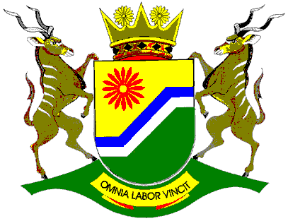

DELIVERY AGREEMENT FOR OUTCOME 7
VIBRANT, EQUITABLE AND SUSTAINABLE RURAL COMMUNITIES WITH FOOD SECURITY FOR ALL
DATE: 08 DECEMBER 2010

LEAD DEPARTMENT: DEPARTMENT OF AGRICULTURE, RURAL DEVELOPMENT AND LAND ADMINISTRATION


TABLE OF CONTENTS
1 MPUMALANGA SITUATIONAL ANALYSIS - AN OVERVIEW 5
1.1 Demographics 5
1.2 Urbanization Rate 8
1.3 Poverty 8
1.4 Income 12
1.4.1 Personal income 12
1.4.2 Household income sources 13
1.5 Employment 14
1.6 Education 15
1.7 Basic Service Infrastructure 16
1.8 GDP Growth 18
1.9 Sectoral Contribution and Performance 19
1.10 Inflation 20
1.11 International Trade 21
2 AGRICULTURE OVERVIEW 23
2.1 Agricultural Land 23
2.2 Soil Potential 24
2.3 Water Resources 26
2.4 Mpumalanga Agriculture Comparative Advantage 26
2.5 Interventions Required 28
2.5.1 Human development aspects 29
2.5.2 Agriculture 29
2.5.3 Employment and job opportunities 29
2.5.4 Education 30
2.5.5 Sanitation 30
2.5.6 Energy 30
2.5.7 Housing 30
2.5.8 Health 31
2.5.9 Sports, Art and Recreation 31
2.5.10 Roads 31
2.5.11 Marketing Infrastructure 31
2.5.12 Waste Management 31
2.5.13 Water connections 31
2.5.14 Access to finance 32
2.5.15 Participatory Development 32
3 THE COMPREHENSIVE RURAL DEVELOPMENT PROGRAME 32
3.1 High Level Problem Statement 32
3.2 Working Definition of Rural Areas 33
3.3 Farmer Support Categories 33
3.4 Delivery Partners for Outcome 7 34
3.5 CRDP Management Systems 35
3.5.1 Political Task Team: 35
3.5.2 Provincial Coordinating Committee 36
3.5.3 Council of Stakeholders at Local Municipality Level 36
4 MPUMALANGA CRDP ROLL - OUT PLAN 37
4.1 Targeting 37
4.2 Outputs for Outcome 7 37
4.2.1 OUTPUT 1: SUSTAINABLE AGRARIAN REFORM, WITH A THRIVING SMALL AND LARGE FARMING SECTOR 38
4.2.2 OUTPUT 2: IMPROVED ACCESS TO AFFORDABLE AN DIVERSE FOOD 44
4.2.3 OUTPUT 3: IMPROVED RURAL SERVICES TO SUPPORT LIVELIHOODS 47
4.2.4 OUTPUT 4: IMPROVED EMPLOYMENT OPPORTUNITIES AND ECONOMIC LIVELIHOODS 51
4.2.5 OUTPUT 5: ENABLING INSTITUTIONAL ENVIRONMENT FOR SUSTAINABLE AND INCLUSIVE GROWTH 55
5 CHALLENGES IN IMPLEMENTING OUTCOME 7 60
5.1 Financial Requirements 60
5.2 Human Resources 60
5.3 Legislative and Institutional Capacity Requirements 61

INTRODUCTION

This Delivery Agreement is a negotiated agreement outlining the commitments from key partners involved in delivering Outcome 7. It provides details to the outputs, targets, indicators and key activities in addition to the roles and responsibilities for achieving Outcome 7. It spells out who will do what, by when and with what resources. The outputs are applicable to the entire government and are long term. While the delivery agreement mainly contains long term outputs and targets, it also includes outputs and targets achievable in the next 3 years (MTEF period).
The Delivery Agreement will be reviewed annually as the department learns from ongoing implementation as well as takes on feedback from monitoring and evaluation (M&E), and gets buy-in from more partners who could be able to leverage effectiveness. This way the agreement without reducing its targets will be refined over time thereby become more inclusive of relevant delivery partners.

MPUMALANGA SITUATIONAL ANALYSIS - AN OVERVIEW

Demographics
The Mpumalanga provincial population is estimated at 3.6 million people representing 7.2% of South Africa’s population. Females constitute 51.2 per cent of the provincial population and males 48.8 per cent. The youth constitutes those between 0-34 years old makes up 71.9 per cent of the total population and the age group 60 years and older, only 6.3 per cent.

The provincial population distribution by district is as follows:

  - Ehlanzeni - 41.6%;
  - Nkangala - 30.1% ; and
  - Gert Sibande - 28.2%.

The average Annual Population Growth rate for Mpumalanga between 2002 and 2010 is estimated at 0.9 per cent compared with the 1.2 per cent recorded nationally. An analysis of the seven focus municipalities comprising Mkhondo, Pixley Ka Isaka Seme , Albert Luthuli, Bushbuckridge, Nkomazi, Dr JS Moroka and Thembisile Hani shows there has been a general increase in the municipality populations ( see Figure 1).

FIGURE 1: POPULATION TREND BY CRDP MUNICIPALITY, 2005 – 2009
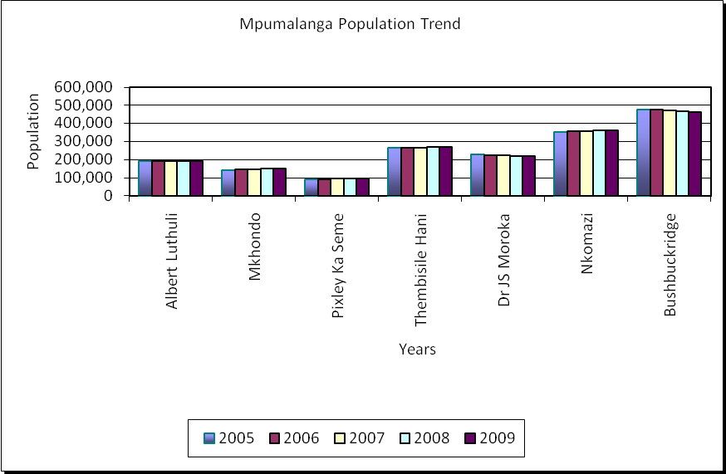
Source: Global Insight – ReX, June 2010

Figure 2 below shows that the population growth rates are decreasing for Mkhondo, Pixley Ka Seme, and Nkomazi; and are increasing for Bushbuckridge, and Dr JS Moroka.

FIGURE 2: SEVEN MUNICIPALITIES ANNUAL POPULATION GROWTH RATE TREND, 2005 - 2009
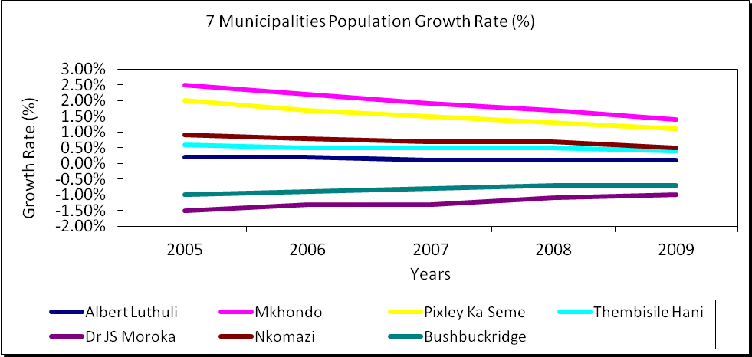 Source: Global Insight – ReX, June 2010

Urbanization Rate

For the CRDP municipalities, Figure 3 shows that the rate of urbanization is highest in Pixley Ka Seme Municipality and is lowest in Bushbuckridge Municipality. The figure also shows that across all municipalities, the rate of urbanization seem to be increasing over time.

FIGURE 3: URBANIZATION RATE BY CRDP MUNICIPALITY, 2001 – 2008

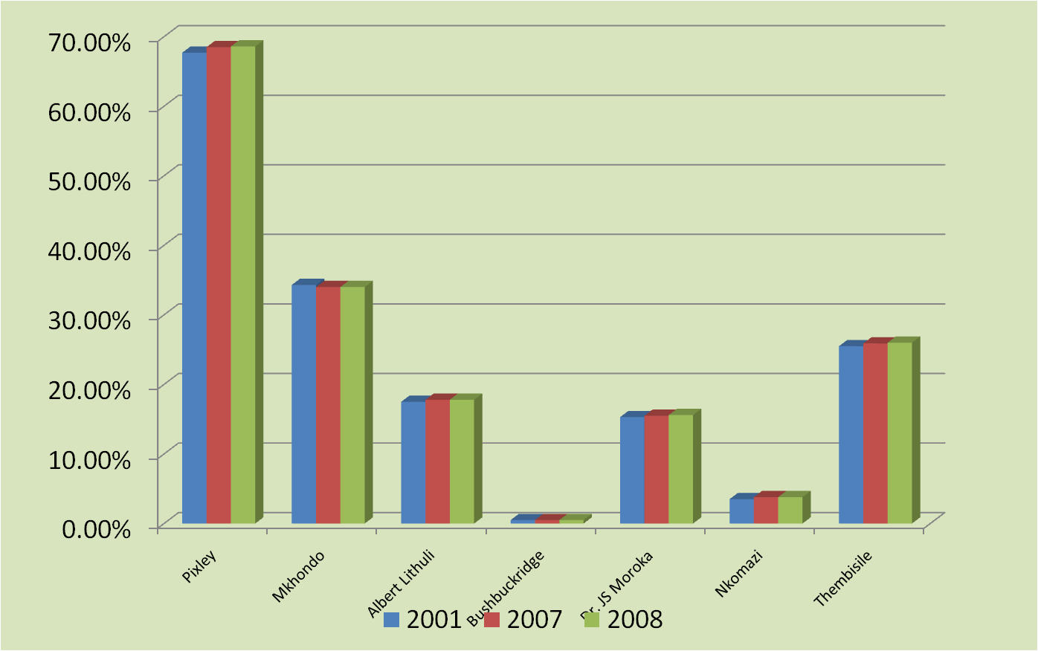
Source: Global Insight – ReX, June 2010

Poverty

Poverty income is defined as the minimum income needed to sustain a household and varies according to the size of the household. The poverty rate then is the percentage of people living in households with an income less than the poverty income.

The Mpumalanga provincial poverty rate stood at 47.8% in 2009 which is higher than the national rate of 42.1% (Figure 4). This translates to 1.79 million people living in poverty in the province with an income less than the poverty income.

Among the three districts, both Ehlanzeni (52.3 %) and Gert Sibande (49.8 %) registered poverty above the provincial rate, whilst Nkangala recorded the lowest rate of 39.8 per cent. With 447 000 people living below the poverty income in 2009, had the lowest number of people in poverty in the province and Ehlanzeni with 813 000, the highest. This could be attributed to the fact that the majority of the population in Nkangala mainly depends on non-agricultural income from the manufacturing industry and formal employment from Gauteng.
FIGURE 4: POVERTY RATES IN SOUTH AFRICA, MPUMALANGA AND DISTRICTS, 1996-2009

Source: Global Insight – ReX, June 2010

An analysis by the CRDP municipalities shows that for 2009, the poverty rate is highest for Mkhondo Municipality and is lowest for Dr. JS Moroka Municipality (Figure 5). The rate of poverty seems to be:

- Steadily decreasing for Albert Luthuli, Bushbuckridge, Dr JS Moroka, and Nkomazi Municipalities; and
- Increasing after initially decreasing for Pixley Ka Seme, Mkhondo, and Thembisile Hani municipalities.

Figure 5: Poverty Rates by CRDP Municipality, 2001 - 2009
Source: Global Insight – ReX, June 2010
The Human Development Index (HDI) is derived from of life expectancy index, education index and income index. An HDI of less than 0.5 indicates low human development; an HDI of 0.5 to 0.79 shows medium development; and an HDI of at least 0.8 shows high human development. All CRDP municipalities have an HDI of less than 0.5 hence there is low human development in the focus municipalities (Figure 6). The HDI is lowest for Nkomazi municipality and highest for Pixley Ka Seme for the period 1996 to 2009.

FIGURE 6: HUMAN DEVELOPMENT INDICES (HDI) BY CRDP MUNICIPALITY, 1996 – 2009
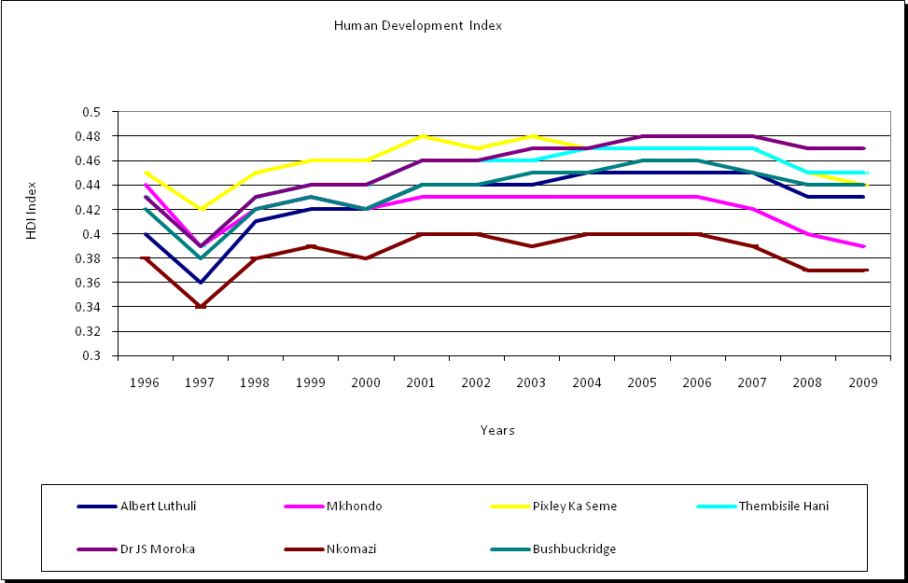
Source: ReX, Global Insight

The Gini coefficient indicates the distribution of wealth in a society. A Gini coefficient of 1 indicates perfect inequality whilst a coefficient of 0 shows perfect equality or distribution of wealth. Figure 7 shows that inequalities have been increasing from 1996 till the mid 2000 across all focus municipalities. The level of inequality is highest in Pixley Ka Seme and lowest in Nkomazi and Thembisile Hani Municipalities.

FIGURE 7: GINI COEFFICIENT BY CRDP MUNICIPALITIES, 1996 – 2009
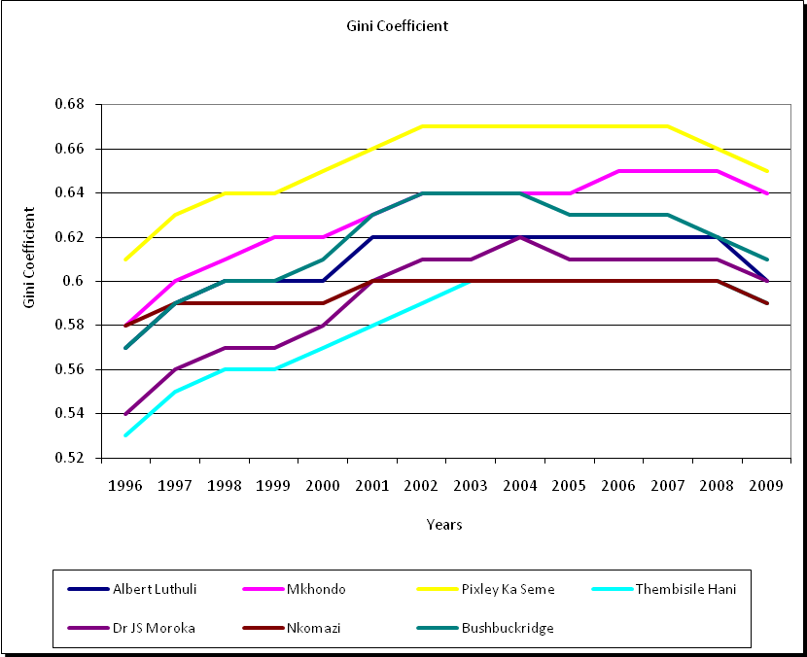
Source: Global Insight – ReX, June 2010

Income

Personal income
Mpumalanga’s Annual Per Capita Personal Income in nominal terms (current prices) showed a noticeable improvement from R7 996 per annum (R666 per month) in 1996 to R26 265 per annum (R2 189 per month) in 2009. However, this was still lower than the national average amount of R34 797 (R2 900 per month). The income data shows that in 2009, the average person in Gert Sibande (R26 657) and Nkangala (R32 385) earned more than the average person in the province. Ehlanzeni recorded the lowest annual per capita income of R21 571 per annum (R1 798 per month) in 2009. This is a reflection of the distribution of the main source of income for the populations with Ehlanzeni being mainly government which can absorb few people and the agricultural industry with minimal income for the people. Nkangala with main concentrations in Emalahleni and KwaMhlanga depend mostly on the manufacturing industries in both Mpumalanga and Gauteng.

Household income sources
In Mpumalanga 62.0 per cent of households received an income from salaries (Figure 6). In 2009, 48.6 per cent of households in Mpumalanga obtained income from grants. Of particular importance to Mpumalanga are the facts that:
- More households in Mpumalanga received income from own businesses (15.2 per cent) than households in South Africa (12.6 per cent) or any of the other eight provinces;
- Remittances (20.1 per cent) made a substantial contribution to household income in Mpumalanga; and
- Nearly 10 per cent of households in Mpumalanga recorded pensions as a source of income in 2009.

FIGURE 8: PERCENT HOUSEHOLDS WITH SOURCES OF INCOME – MPUMALANGA PROVINCE
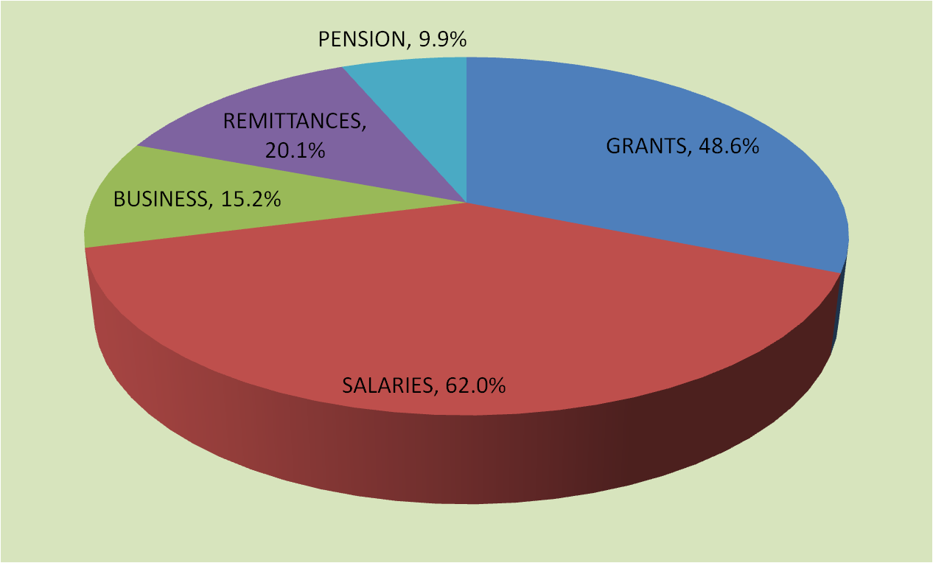

Source: Global Insight – ReX, June 2010

Employment
Mpumalanga’s total employment of 881 000 employees in the third quarter of 2009 decreased to 867 000 in the second quarter of 2010. Table 1 shows the aggregated employment composition of employment in the province from the third quarter of 2009 to the second quarter of 2010.

TABLE 1: AGGREGATE EMPLOYMENT IN MPUMALANGA, 2009-2010 BY SECTOR
Sector | Q3 2009 | Q4 2009 | Q1 2010 | Q2 2010
Formal sector | 59.8% | 59.7% | 60.6% | 60.0%
Informal sector | 20.7% | 23.2% | 21.5% | 21.5%
Agriculture | 8.4% | 7.5% | 7.6% | 8.5%
Private households | 11.1% | 9.6% | 10.3% | 10.0%
Source: Global Insight – ReX, June 2010

The unemployment rate for Mpumalanga province is estimated at 28.1 % for the second quarter of 2010. An analysis by district shows that the unemployment rate for 2009 is 23.9%, 26.2%, and 18.4% for Gert Sibande, Nkangala, and Ehlanzeni, respectively. Figure 9 shows that the rate of unemployment is highest in Dr. JS. Moroka Municipality and is lowest in Nkomazi Municipality. The figure also shows that across all municipalities, the unemployment rate seem to be steadily decreasing over time across all municipalities except for Dr. JS Moroka and Bushbuckridge municipalities.

FIGURE 9: UNEMPLOYMENT RATE (%) BY CRDP MUNICIPALITY, 2001 – 2009

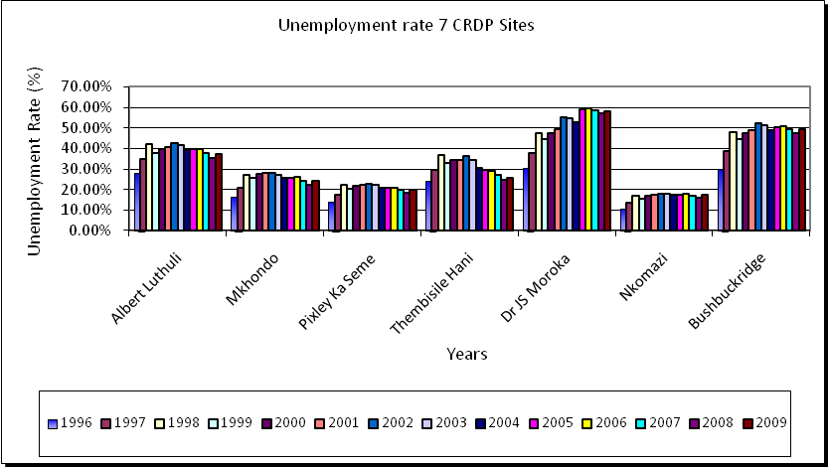
Source: Global Insight – ReX, June 2010

Education
There is a direct correlation between the educational attainment and employment growth rate. Higher employment growth rates are observed among those who have a higher level of education. An analysis of the education profile of the province therefore provides vital information pertaining to employability of the labour force, as well as insight into the potential employment growth.

In 2009, 14.2% or some 354 300 of the people 15 years and older have not received any schooling. However, this shows an improvement compared to the unacceptably high level of 23.2 % or some 507 300 in 2001. However, this is still below the national level of 9.3 % in 2009. Only 7.0% have post-grade 12 qualifications. The number of people with no schooling has been decreasing from 2005 to 2009 for all the focus municipalities whilst the number of people with matric only has been increasing (Figure 10).

FIGURE 10: NUMBER OF PERSONS WITH NO SCHOOLING OR WITH MATRIC ONLY BY CRDP MUNICIPALITY, 2005 - 2009
Source: Global Insight – ReX, June 2010

Basic Service Infrastructure
The delivery of basic services is essential in improving the quality of life and sustainable development for communities. Table 2 illustrates the key basic services delivery for Mpumalanga. Overall, service delivery is highest for electricity (about 82% of the households) and is lowest for refuse removal (46% of the households). Provision of hygienic toilets, piped water and formal refuse removal is highest in Gert Sibande. The provision of electricity is highest in Nkangala. The provincial infrastructure index level (0 indicates no delivery and 1 indicates full delivery) was at 0.74, which was slightly lower than the national index at 0.77. Among the three districts in the province, Gert Sibande registered the highest infrastructure index level at 0.79, whilst Ehlanzeni with an index level of 0.68 ranked the lowest.

TABLE 2: FIVE KEY BASIC SERVICE DELIVERY INFRASTRUCTURE INDICATORS BY DISTRICT, 2009
INDICATORS | MPUMALANGA | GERT SIBANDE | NKANGALA | EHLANZENI
% of households with hygienic toilets | 54.1% | 75.7% | 49.4% | 42.9%
% of households with piped water at  or above RDP level | 77.1% | 84.5% | 83.0% | 67.8%
% of households with electricity connections | 82.3% | 81.0% | 85.0% | 81.3%
% of households with formal refuse removal | 45.9% | 59.9% | 48.5% | 34.6%
Infrastructure index | 0.74 | 0.79 | 0.77 | 0.68
Source: Global Insight – ReX, June 2010

Table 3 shows an analysis by CRDP municipality which indicates that:

- Bushbuckridge has the lowest percentage households with access to all basic services;
- The percentage of households with access to piped water is highest in Thembisile Hani Municipality (86%);
- The percentage households with electricity connections is highest in Mkhondo Municipality (82%); and
- The percent households with formal refuse disposal are highest in Pixley Ka Seme Municipality (58%);

TABLE 3: BASIC SERVICE DELIVERY INFRASTRUCTURE INDICATORS BY CRDP MUNICIPALITY, 2009
Indicators | Nkomazi | Bush buck ridge | Albert Luthuli | Mkhondo | Pixley Ka Seme` | Dr JS Moroka | Thembisile Hani
% of households with hygienic toilets | 52.0% | 8.0% | 34.5% | 65.3% | 75.4% | 24.2% | 6.9%
% of households with piped water at or above RDP level | 73.0% | 47.1% | 75.2% | 71.9% | 77.7% | 61.6% | 86.0%
% of households with electricity connections | 80.6% | 65.4% | 69.2% | 82.4% | 69.6% | 73.2% | 76.5%
% of households with formal refuse removal | 45.6% | 4.3% | 20.9% | 47.8% | 57.6% | 13.4% | 13.6%
Source: Global Insight – ReX, June 2010

GDP Growth
In 2009, Mpumalanga contributed R116.5 billion at constant 2005 prices to the GDP of South Africa. The economic recession that spanned from the end of 2008 until midway through 2009, resulted in negative GDP growth for 2009 of 3.3 % for Mpumalanga (Figure 9). The average annual growth rate for Mpumalanga over the period 1996 to 2009 2.5 %. Over a 13-year period (1997 – 2009) the growth rates of the economies of the three districts of Mpumalanga are 3.0 % for Nkangala, 2.4 % for Gert Sibande, and 2.1% for Ehlanzeni.

FIGURE 11: GDP (CONSTANT 2005 PRICES) GROWTH RATES FOR SOUTH AFRICA AND MPUMALANGA, 1997-2014

Source: Global Insight - ReX, June 2010

Sectoral Contribution and Performance
Figure 12 shows the contribution of each of the economic sectors in Mpumalanga to the national gross value added (GVA) in 2001 and 2009. In 2009, the province was a substantial role-player in the national mining and utilities (mainly electricity) sectors, with respective shares of 19.9 per cent and 14.5 per cent. Agriculture contributed 8.8% to the national GVA.

FIGURE 12: MPUMALANGA’S CONTRIBUTION TO SOUTH AFRICA’S GVA (CONSTANT 2005 PRICES) BY SECTOR, 2001 AND 2009

Source: Global Insight - ReX, June 2010

In 2009, the three largest contributors to the provincial economy were manufacturing (18.8 %), mining (17.7 %) and community services (17.6 %). Agriculture contributed 3.3% and tourism 3% to the provincial economy. This was slightly different from 2001, when mining (22.7 %) was the leading sector followed by manufacturing (19.4 %) and community services (16.7 %).

Table 4 displays the share of each economic sector in the three districts’ economies in 2009. The manufacturing sector dominated the district economy of Gert Sibande in 2009 with a 33.3 % share. Mining activities dominated the Nkangala economy as it added 30.0 % to the district’s economy in 2009. The largest contributing sector in Ehlanzeni in 2009 was community services with a share of 27.8 %.

The primary sectors in Mpumalanga contributed 21.0 %, secondary sectors 26.3 % and tertiary sectors 52.7 % to the provincial GVA in 2009. Although the economy depended less on the primary sectors in 2009 than in 2001 (26.3 %), it continued to stand in contrast to the national primary sectors’ small contribution of 8.3 % in 2009. Nationally, the secondary sectors added 22.5 % and the tertiary sectors 69.3 % in 2009. Economic growth of primary sector was 0.5%, secondary sector 2.8%, and tertiary sector 3.8% from 1996 to 2009.

TABLE 4: SECTORAL CONTRIBUTION TO INDIVIDUAL DISTRICTS’ GVA (CONSTANT 2005 PRICES), 2009
SECTOR | MPUMALANGA | GERT SIBANDE | NKANGALA | EHLANZENI
Agriculture | 3.3% | 4.4% | 1.9% | 4.1%
Mining | 17.7% | 14.3% | 30.0% | 4.2%
Manufacturing | 18.8% | 33.3% | 12.1% | 12.3%
Electricity | 5.0% | 4.0% | 8.9% | 0.5%
Construction | 2.6% | 2.2% | 2.1% | 3.7%
Trade | 11.7% | 9.5% | 8.7% | 18.4%
Transport | 9.4% | 7.5% | 8.7% | 12.7%
Finance | 13.9% | 12.2% | 13.4% | 16.4%
Community service | 17.6% | 12.7% | 14.2% | 27.8%
Total | 100.0% | 1000% | 100.0% | 100.0%
Primary sectors | 21.0% | 18.7% | 32.0% | 8.3%
Secondary sectors | 26.3% | 39.5% | 23.1% | 16.4%
Tertiary sectors | 52.7% | 41.9% | 18.7% | 75.3%
Source: Global Insight - ReX, June 2010

Inflation
The most common way to measure inflation is by reference to a Consumer Price Index (CPI), which measures the changes in prices of a basket of goods and services purchased by a representative household. Mpumalanga’s average annual inflation rate of 8.2 % in 2009 was higher than the 7.1 % measured for the whole of South Africa (Figure 11). However, Mpumalanga’s inflation rate dipped below that of South Africa over the first seven months of 2010. The July 2010 inflation measurement in Mpumalanga of 3.3 % was markedly lower than the national level of 3.7 %. The main determinants of inflation in Mpumalanga are price changes in food and non-alcoholic beverages, housing and utilities, transport as well as miscellaneous goods and services.
FIGURE 13: CPI (YEAR-ON-YEAR) IN SOUTH AFRICA AND MPUMALANGA, JAN 2009 – JULY 2010

Source: Statistics South Africa – CPI Additional Tables, 2009 & 2010

International Trade
Mpumalanga’s contribution to total national trade was 1.2 % in 2009, down from 1.5 % in 2001. Mpumalanga contributed 1.6 % and 0.7 % to national exports and national imports respectively. The low level of contribution could be attributed to the fact that most exports from Mpumalanga leave from Gauteng or the South East Coast (Durban, Cape Town and Port Elizabeth). For the exports to increase there is a need to promote the use of Maputo Corridor and the Kruger Mpumalanga International Airport which was partly constructed to promote international trade from the province.

Mpumalanga recorded vigorous average annual growth in terms of exports (11.0 %) and imports (13.7 %) from 1996 to 2009. Despite surpassing the comparative national import growth rate, the province failed to grow exports faster than the country as a whole over the 13-year period. This could be attributed among others to lower productivity from slow progress in finalizing land reform and the under developed agricultural value chain in the province. The development of the comprehensive fresh produce market linking agri-parks should improve the increase in provincial and national exports from Mpumalanga.

Among the three districts, Nkangala with 44.1 % proportion of exports was the main contributor to provincial exports in 2009 followed by Ehlanzeni and Gert Sibande with contributions of 31.5 % and 24.4 %, respectively (see Table 4). Exports from Gert Sibande (21.2 %) recorded the highest growth since 1996 and those from Ehlanzeni the slowest (8.3 %). Gert Sibande attracted 68.0 % of Mpumalanga’s imports in 2009, followed by Nkangala and Ehlanzeni. Imports flowing to Gert Sibande recorded the highest growth rate (14.7 %) over the 13-year period and those to Ehlanzeni the lowest (10.8 %). Table 5 presents the districts’ contribution to provincial trade as well as providing average annual growth rates for the respective flows over the 13-year period.

TABLE 5: MPUMALANGA DISTRICTS’ CONTRIBUTION TO PROVINCIAL EXPORTS AND IMPORTS, 2009
DISTRICT | EXPORTS |  | IMPORTS
DISTRICT | Provincial share | Growth 96 - 09 | Provincial share | Growth 96 - 09
Gert Sibande | 24.4% | 21.2% | 68.0% | 14.7%
Nkangala | 44.1% | 10.2% | 23.1% | 12.6%
Ehlanzeni | 31.5% | 8.3% | 8.9% | 10.8%
Source: Global Insight - ReX, June 2010

Among the three districts, Nkangala recorded the largest positive trade balance of R3.1 billion in 2009, followed by Ehlanzeni (R2.5 billion). Gert Sibande recorded a negative trade balance in 2009 of R328 million and are the only district in Mpumalanga to sporadically record negative trade balances relative to the period before 2005.

In 2009, exports from Mpumalanga to the world were dominated by manufactured goods (54.4 %) and primary products of mining activities (36.0 %). Exports of manufactured goods consisted primarily of metal products, machinery and household appliances, whilst exports of mining products consisted mainly of coal. Exports from Gert Sibande were dominated by primary mining products (77.0 %), Nkangala by manufactured goods (57.1 %) and Ehlanzeni similarly by manufactured goods (79.5 %).
In 2009, imports from Mpumalanga to the world were dominated by manufactured goods
(97.6 %). Imports destined for Gert Sibande (99.4 %), Nkangala (99.0 %) and Ehlanzeni (80.1 %) whereby and large manufactured goods. These manufactured goods consisted primarily of metal products, machinery and household appliances as well as electrical machinery and apparatus.

AGRICULTURE OVERVIEW

Agricultural Land
The Mpumalanga land cover and potential crop are presented in Table 6. Overall, only 19% of the total provincial area is estimated potential area that can be cropped. The land area is distributed as follows:

- 16.7% is under commercial dry land;
- 1.7% is under commercial irrigation; and
- 1.53% is under subsistence agriculture.

An analysis by district shows that the percent area under commercial agriculture is highest in Nkangala (23.25%); the percent area under commercial irrigation is highest in Ehlanzeni (5.5%); and the percent area under subsistence agriculture is highest in Ehlanzeni (3.53%).
TABLE 6: MPUMALANGA LAND COVER AND ESTIMATED CROP POTENTIAL AREA
DISTRICT |  | MUNICIPALITY | TOTAL AREA | COMMERCIAL DRY LAND | COMMERCIAL IRRIGATION | SUBSISTENCE AGRICULTURE | CROP POTENTIAL AREA (%)
Ehlanzeni District |  | Bushbuckridge | 258 926 |  |  | 38 023 | 14.68%
 |  | Mbombela | 341 175 | 12 817 | 23 170 | 6 706 | 12.51%
 |  | Nkomazi | 324 030 | 3 986 | 53 423 | 12 680 | 21.63%
 |  | Thaba Chweu | 571 906 | 28 935 | 11 119 | 1 582 | 7.28%
 |  | Umjindi | 174 538 | 10 941 | 4 123 | 0 | 8.63%
EHLANZENI DISTRCT TOTAL |  |  | 1 670 575 | 56 679 | 91 835 | 58 991 | 12.42%
Gert Sibande  District | Albert Luthuli |  | 555 939 | 37 817 | 7 540 | 8 258 | 9.64%
Gert Sibande  District | Dipaleseng |  | 261 656 | 99 621 | 1 177 | 0 | 38.52%
Gert Sibande  District | Govan Mbeki |  | 295 469 | 98 950 | 283 | 0 | 33.58%
Gert Sibande  District | Lekwa |  | 458 419 | 181 961 | 1 374 |  | 39.99%
Gert Sibande  District | Mkhondo |  | 488 217 | 37 777 | 476 | 6 183 | 9.10%
Gert Sibande  District | Msukaligwa |  | 601 567 | 99 420 | 376 | 284 | 16.64%
Gert Sibande  District | Pixley Ka Seme |  | 522 723 | 86 338 | 675 | 2 358 | 17.10%
GERT SIBANDE DISTRICT TOTAL |  |  | 3 183 990 | 641 884 | 11 900 | 17 084 | 21.07%
Nkangala  District | Victor Khanye |  | 156 778 | 90 280 | 731 | 0 | 58.05%
Nkangala  District | Dr JS Moroka |  | 141 647 | 3 145 | 7 | 23 610 | 18.89%
Nkangala  District | Emakhazeni |  | 473 559 | 51 721 | 3 189 | 0 | 11.60%
Nkangala  District | Emalahleni |  | 267 761 | 77 114 | 748 | 0 | 29.08%
Nkangala  District | Steve Tshwete |  | 397 645 | 143 033 | 1 064 | 0 | 36.24%
Nkangala  District | Thembisile |  | 238 435 | 24 354 | 1 259 | 25 | 10.75%
NKANGALA DISTRICT TOTAL |  |  | 1 675 825 | 389 646 | 6 999 | 23 635 | 25.08%
MPUMALANGA TOTAL |  |  | 6 530 390 | 1 088 209 | 110 734 | 99 710 | 19.89%
Source: DARDLA Research Unit

Soil Potential
An analysis of the soil quality is the province is represented in Figure 14. About 50% of the province constitute of soils of low quality for agriculture production purposes. Only 23% of the provincial land area constitutes soils of high potential. This information is complemented by Figure 15 which presents the spatial distribution of the provincial soil potential.

FIGURE 14: MPUMALANGA SOIL POTENTIAL QUANTITATIVE ANALYSIS
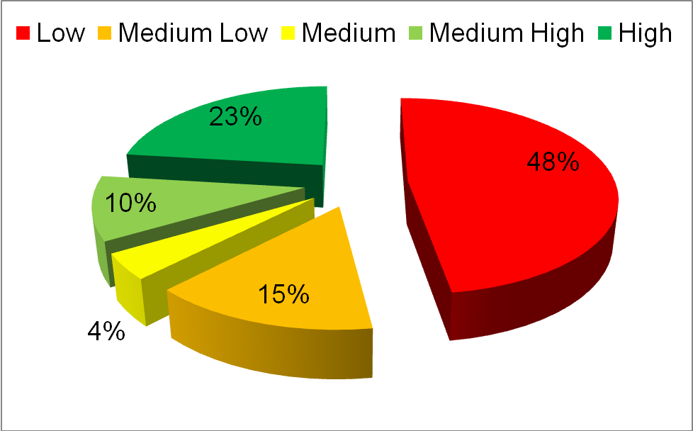
Source: DARDLA Research Unit

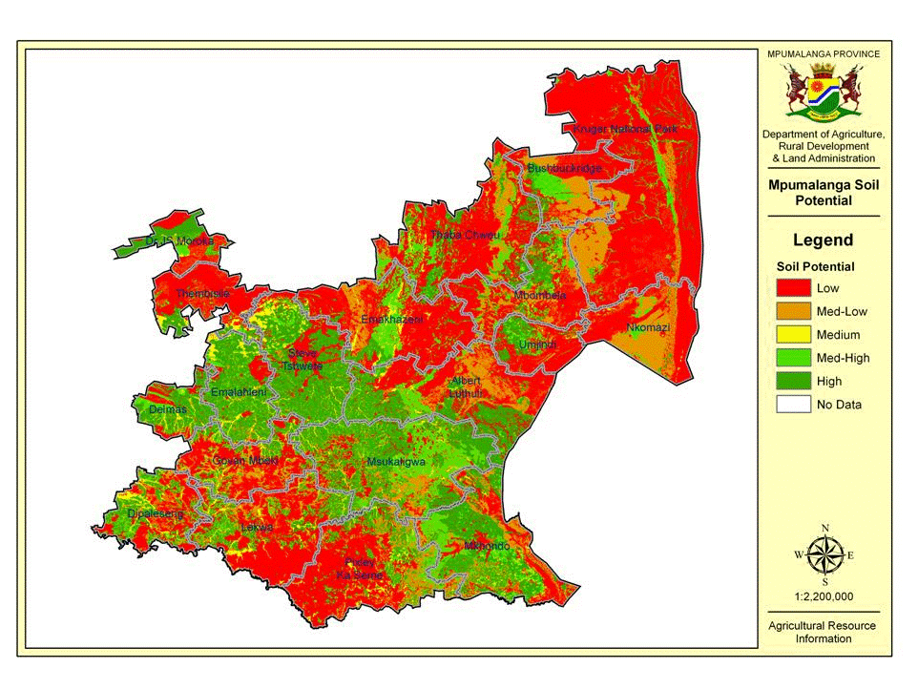
FIGURE 15: A SPATIAL DISTRIBUTION OF SOIL POTENTIAL FOR AGRICULTURE PRODUCTION, IN MPUMALANGA
Source: DARDLA Research Unit

Water Resources
There are two major water management or catchment areas in the province, the Olifants (River) and Inkomati (River) Water Management Areas. In both water management areas, the water demand surpasses water supply (Figure 14). The water deficit is higher in the Inkomati Water Management Area (about 20% deficit compared about 3% deficit in the Oliphant’s).

FIGURE 16: WATER AVAILABILITY AND REQUIREMENTS IN THE INKOMATI AND OLIPHANT’S WATER MANAGEMENT AREAS
Annual Water Demand and Supply for the Inkomati
Annual Water Demand and Supply for the Oliphant’s

Source: International Water Management Institute.

Mpumalanga Agriculture Comparative Advantage

The location quotient is an indication of the comparative advantage of an economy. An economy has a location quotient larger (smaller) than one, or a comparative advantage (disadvantage) in a particular sector when the share of that sector in the provincial economy is greater (less) than the share of the same sector in the national economy.

In Mpumalanga, agriculture (1.15), mining (2.99) and utilities (1.97) held a comparative advantage over the same sector in the national economy in 2009. The contribution by manufacturing (0.97), construction (0.74), trade (0.79), transport (0.79), finance (0.55) and community services (0.71) to the provincial economy, were lower than the contribution by the same sectors to the national economy.
Within the province, Gert Sibande held a comparative advantage in the same three sectors as the province as well as in manufacturing. Nkangala’s contribution to mining and utilities was much higher than the contribution by the same sectors to the provincial economy. Except for finance, Ehlanzeni showed comparative advantage in the sectors in which the province held a disadvantage.

Table 7 shows the major crops and livestock for which Mpumalanga has a comparative advantage for production over other provinces. Similarly, the province seems to have a comparative advantage in the following crops: soya beans, banana, and citrus production. But mostly, the province seems to have the most comparative advantage in poultry production and processing.

Besides soya beans, banana, and citrus, the province also has a comparative advantage in sugar cane (Table 8) production. Sugar cane accounts for 73% of the irrigated surface in Nkomazi. Sugar cane produced in the Nkomazi area produces more sucrose than the rest of South Africa and most of the sugar producing countries worldwide. Therefore it will be ideal for the sugar cane from Mpumalanga to remain producing sugar while the other areas focus on bio-fuel). Thirty two per cent (32%) of the Industry supplies are procured from black owned companies with the commitment to grow this to 50%. The sugar cane industry directly employs 77 000 people in South Africa with 350 000 indirect jobs supported.

It is however important to note that water use and availability remains critical for sustainable production of sugar cane. Water use efficiency is therefore a necessary intervention to support sugar production and Nkomazi economy. There are plans to build an additional dam, which however needs an integrated approach with DWA.

TABLE 7: MPUMALANGA AGRICULTURE COMPARATIVE ADVANTAGE
COMMODITY | TOTAL RSA PRODUCTION  (‘000 TON) | TOTAL PRODUCTION MPUMALANGA PROVINCE (‘000 TON) | PERCENTAGE SHARE MPUMALANGA | RANKING
Maize | 12,050 | 2,870 | 24% | 2nd
Sorghum | 27,650 | 66,000 | 24% | 2nd
Soya beans | 516,600 | 262,500 | 51% | 1st
Sunflower | 801,000 | 37,500 | 5% | 3rd
Dry beans | 67,030 | 15,750 | 23% | 2nd
Citrus | 2,285,384 | 685,615 | 32% | 2nd
Banana | 405,000 | 145,800 | 36% | 2nd
 | TOTAL RSA PRODUCTION  (NO. OF ANIMALS) | TOTAL PRODUCTION MPUMALANGA PROVINCE  (NO. OF ANIMALS) | PERCENTAGE SHARE MPUMALANGA | RANKING
Cattle | 14,850,000 | 1,485,000 | 10% | 5th
Sheep | 25,528,571 | 1,787,000 | 7% | 5th
Goat | 2,077,000 | 95,036 | 5%
Poultry | 3,185,000 | 573,300 | 18% | 3rd
Source: DAFF, Abstract of Agricultural Statistics, 2010

TABLE 8: MPUMALANGA COMPARATIVE ADVANTAGE IN SUGAR CANE PRODUCTION
COMMODITY | TOTAL RSA | TOTAL MPUMALANGA | PERCENTAGE
Area Planted (ha) | 405 000 | 44 000 | 11%
Tonnage | 18 655 089 | 4 561 596 | 24%
No. Mills | 14 | 2 | 14%
Employment | 77 000 | - | -
No. Small Scale Growers | 33 742 | 1242 | 3.6%
Large Scale Growers | 1577 | 179 | 11.3%
Source: DAFF, Abstract of Agricultural Statistics, 2010

Interventions Required
Based on the brief situation analysis, there is a need to implement programmes and projects that can accelerate the rate of poverty alleviation to improve livelihoods. The following is a summary of interventions required to improve the rural livelihoods in Mpumalanga province particularly for the target CRDP municipalities:

Human development aspects
- Implement interventions to improve human capital through skills development, capacity and involvement including promoting local entrepreneurship and increase employment.
- Come up with incentives to attract educated personnel to work and stay in the rural municipalities in order to promote local economic development.

Agriculture
- Improve water allocation and efficiency for agriculture production.
- Develop and promote the adoption of efficient irrigation systems.
- Develop and implement systems that reduce the competition between grazing and human settlement for land.
- Put in place systems of maintaining international fences in order to control trans-boundary diseases.
- Improve post settlement support for land reform farms.
- Youth need to be encouraged through relevant programmes and projects to be involved in agriculture and in other sectors.
- There is also a need to convert the Marapyane College of Education to an Agricultural Training Centre so as to encourage the community to attend and enquire knowledge and skills in Agriculture.

Employment and job opportunities
- Invest in labour intensive technologies across the sectors to create jobs.
- Promote community tourism for those communities bordering the Kruger National Park.
- Establish community and labour intensive technologies / expertise for roads construction and maintenance.
- To create job opportunities through EPWP programme during projects development (CASP, LAND CARE and ME).
- Create job opportunities by growing the cooperative movement support to SMMEs.

Education
- Those who did not attend school needs to be empowered through ABET coupled vocational training (e.g. through the Mpumalanga Regional Training Trust (MRTT)).
- There is need to increase the number of schools and teachers to cater for the increasing population of learners.
- To increase the number and quality of farm schools.

Sanitation
- There is a need to improve and accelerate the provision of sanitation facilities in rural areas in order to promote healthy living environments.
- This will contribute to the Millennium Development Goal (MDG) target to halve the proportion of people without sustainable access to safe drinking water and basic sanitation by 2015.

Energy
- There is need to decrease the extent of use of firewood and coal as sources of energy so as to reduce deforestation and environmental degradation.
- Promote sustainable electrification in rural areas by using renewable energy sources such as solar and wind energy in order to increase household opportunities.
- This will contribute to the achievement of the MDG of Ensuring Environmental Sustainability.

Housing
- The demand for Human Settlement will increase with the increase in population. There is a need to increase the pace of provision of RDP houses in order to reduce homelessness.

Health
- To improve access to health services by increasing the provision of health centres, mobile health facilities and increasing hours of access to health services per day.
- To promote primary health awareness (e.g. through primary health awareness campaigns).

Sports, Art and Recreation
- There is need for robust development of sporting facilities to promote social cohesion and create opportunities for networking through promoting indigenous sports in rural areas.

Roads
- Improve the quality of road infrastructure through labour intensive methods to promote job creation and increase household income.

Marketing Infrastructure
- Develop and improve market and storage infrastructure in order to reduce transaction costs for farmers.

Waste Management
- Improve waste disposal management in order to promote healthy living environments.
- This will contribute to the MDG of Ensuring Environmental Sustainability.

Water connections
- Improve the provision of piped water to households to reduce the risk of water borne diseases.
- This will contribute to the MDG target to halve the proportion of people without sustainable access to safe drinking water and basic sanitation by 2015.

Access to finance
- Improve access to finance for entrepreneurs to contribute towards local economic development.

Participatory Development
- To promote inclusive local economy development through the concerted, coordinated action of all municipal departments, government spheres and sectors, the private sector, traditional leaders, civil society and communities involvement in CRDP.

THE COMPREHENSIVE RURAL DEVELOPMENT PROGRAME

High Level Problem Statement
Mpumalanga Province continues to face several problems which constitute the following key aspects:
- Rural areas continue to be marginalised economically and are highly dependent on social grants;
- Mpumalanga houses five of the former homelands namely former Kangwane, Kwa Ndebele, Gazankulu, part of Lebowa and Bophuthatswana with high incidences of poverty and food insecurity;
- A combination of challenges such as droughts and high costs of production, made communities abandon the culture of sustainable household food production;
- As a result the Province introduced Masibuyele Emasimini Programme to mobilize rural households back to agriculture and food production; the province is still facing a challenge of empowering the farmers to graduate from subsistence to commercial agriculture as well as facilitating agro-processing.
- Unskilled labour force.
- Lack of interest from youth in agriculture (low incentives).
- Declining share of contribution of agriculture to the economy.
- Sectoral determination of farm workers act – job shedding and over-reliance on illegal foreign workers (Mozambique, Swaziland & Zimbabwe); and
- Agriculture regarded as the main solution to rural development.

The situational analysis presented above in most cases does not include contribution from the small-scale farmers and other black (new) entrants.

Working Definition of Rural Areas
The generally accepted definition of rural areas tends to refer to the following:
- The sparsely populated areas in which people farm or depend on local natural resources;
- Include villages and small towns that are dispersed throughout these areas with economies mainly based on farming; and
- Include the large settlements in the former homeland areas which depend on migratory labour remittances and social grants for their survival.

Farmer Support Categories

Support to farmers will be differentiated according to the following farmer categories:

Subsistence/resource-poor farmers:
- Due to resources constraints and limited use of technology subsistence farmers produce food to supplement household food needs, with little or no selling of produce to the market.
Smallholder farmers:
- Smallholder farmers produce food for home consumption and market surplus produce.
- The more successful farmers graduate into the commercial category whilst the less successful ones will sometimes regress into the resource-poor/subsistence category.
- This farmer category is intermediate between subsistence and commercial sub-sectors.
Commercial farmers:
- Produce primarily for the market and make considerable living from farming.

Delivery Partners for Outcome 7
In order to effectively deliver the delivery agreement, it is essential that the department works closely with other partners in order to leverage its capacity. Additionally, rural development is a cross cutting programme that calls for partnerships with multi-stakeholders both within and outside government. To this effect the implementation forum will consist of DARDLA as the coordinating department and other core departments. Other relevant departments and stakeholders will be part of task teams per output. Task teams will co-opt other departments and stakeholders from other outcome forums as and when necessary.

STRATEGIC DELIVERY PARTNERS
PARTNER | CONTRIBUTION
COGTA | Development of IDPs and infrastructure development
DHS | Integrated Human settlement
DPWRT | Rural infrastructure development (access roads, bridges)
DEDET | Economic research i.e. monitor labour trends, registration of business entities, access to markets (finance, produce, labour), value chain assessments (Stages 2 & 3 of development rural industries)
DBE | Provision of the integrated schooling programme and early childhood centres among others.
DSD | Provision of social grants, food parcels, vouchers, early childhood development, and emergency relief.
Development Finance institutions | Development finance for resuscitating ailing farms and rural enterprises (both on-farm and off-farm)
Municipalities | Local space, institutional arrangement, Bulk infrastructure
DWA | Bulk water supply, distribution of water rights and management
StatsSA | Statistical information, i.e. CPIX, CPI
Private Sector | Public Private Partnerships to leverage government capacity on service delivery e.g. Mondi, mining sector and Telkom services and their Corporate Social Investment
NGOs and other institutions of learning | Civic/ Community facilitation, promotion of accountability, implementation, Technical assistance and research

CRDP Management Systems

Political Task Team:
- MEC – DARDLA (Chair)
- MEC – COGTA
- MEC – Human Settlement
- MEC – Safety & Security
- 3 District Executive Mayors

Provincial Coordinating Committee
- HOD – DARDLA (Chair)
- DRDLR
- Department Representatives
- Key Private Sector Representatives (Mondi, Save the Children Fund, Vodacom, TSB)
- STATSSA
- IDT
- GTZ
- DWA

Council of Stakeholders at Local Municipality Level
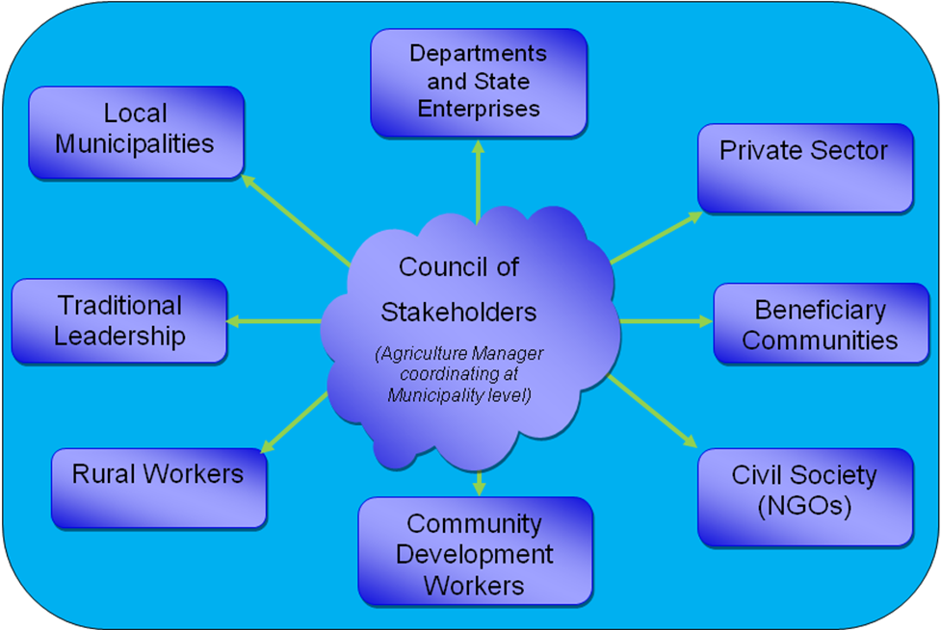

MPUMALANGA CRDP ROLL - OUT PLAN

Targeting
- The 7 municipalities contributes to 47.8% of MP
- CRDP target 45% of the 7 municipalities
- 22% of the provincial population
DISTRICT MUNICIPALITY | LOCAL MUNICIPALITY | TOTAL POPULATION | TARGETTED POPULATION UNDER CRDP & ME | FOCUSSED WARDS
Ehlanzeni | Nkomazi | 509,979 | 153,239 | 16, 17
Ehlanzeni | Bushbuckridge | 338,098 | 229,491 | 30, 33, 34
Gert Sibande | Albert Luthuli | 194,008 | 87,304 | 11, 18
Gert Sibande | Mkhondo | 106,459 | 65,000 | 1 to 19
Gert Sibande | Pixley ka Seme | 65,928 | 26,371 | 6, 10
Nkangala | Dr JS Moroka | 246,965 | 111,134 | 21, 20, 24
Nkangala | Thembisile Hani | 278,518 | 111,407 | 8, 9
TOTAL TARGETS |  | 1,739,955 | 783,946

Outputs for Outcome 7

The following are the outputs that address Outcome 7:
Output 1: Sustainable agrarian reform with a thriving small and large farming sector
Output 2: Improved access to affordable and diverse food
Output 3: Improved rural services to support livelihoods
Output 4: Improved employment opportunities and economic livelihoods
Output 5: Enabling institutional environment for sustainable and inclusive growth

OUTPUT 1: SUSTAINABLE AGRARIAN REFORM, WITH A THRIVING SMALL AND LARGE FARMING SECTOR

Problem statement
- Most of the transferred land is not productive and has not created economic benefits for new owners
- Delays in the land restitution process has actually added to food insecurity as large tracts of arable land are out of production
- Many farm owners have stopped long-term investment due to the uncertainty of the outcome of the restitution process
- Community dynamics and in- fighting has also contributed to the failure of restituted projects questioning the institutional models of these projects
- Inefficiency in rural financial/credit markets – Land Bank’s role not fully developmental
- Lack of skills amongst the land reform beneficiaries and Agricultural Advisors – move from subsistence farming to commercial farming
- High input production costs – low or negative profit margins
- Low public sector investment in Agriculture

Key activities
- Facilitate access by farmers to specialized advisory services (e.g. finalize the Extension Recovery Plan – Advisory Commodity Experts and Strengthen the farmer to farmer mentorship programme)
- Implement a set of levers / interventions developed to support targeted agro-processing industries under IPAP II to deliver jobs and contribute to exports
- Promote an institutional buying program to encourage public institutions such as Correctional Services Departments, hospitals and other private owned institutions to procure agricultural products from small farmers. This will be linked to AgriBEE Charter
- Facilitate contract farming as a model to link farmers with markets
- Implement sustainable farming models
- Facilitate institutionalization small farmers into cooperatives or agri-business associations
- Implement the Masibuyele Emasimini Programme
- Continue to provide agricultural infrastructure support – increase budget on Agriculture
- Fast-track the Land Reform process
- Facilitate conflict management and reduction sessions on restituted farms where there is in-fighting
- Develop ownership models with the full participation of affected communities
- Engage financial institutions to develop more inclusive financial products and specific products for smallholder farmers
- Increase access to development finance by smallholder farmers
- Facilitate and promote the rehabilitation of irrigation schemes
- Develop and / or facilitate the adoption of rainwater harvesting technologies
- Promote water conservation and demand management
- Construction of boreholes and provision of water tanks in targeted areas

KEY PARTNERS:
PARTNER | CONTRIBUTION
COGTA including Local Municipalities | Development of IDPs and infrastructure development
DEDET | Monitor labour and employment trends in the sector. Adoption of labour intensive technologies. Provide technical support. Access to credit and loans. Access to Markets. Mentorship Support. Provide Monthly Consumer Price Index Reports. Development of Value Chains
DWA | Facilitate registration of smallholder farmers with water user associations so that they have water user rights.
StatsSA | Statistical information, i.e. Household survey  Provide infrastructure support to implement water saving technologies.
Financial Institutions | Provide development finance, e.g. credit and loans.

PERFORMANCE INFORMATION: OUTPUT 1 - SUSTAINABLE AGRARIAN REFORM, WITH A THRIVING SMALL AND LARGE FARMING SECTOR
Output | Indicator/ Measure  (National) | Key Activities | Baseline | 5-yr Targets | 2010/11 Targets | MTEF Budget  “R” (millions) | 2010/11 Budget  “R” (millions) | Lead Dept | Key Partners
Sustainable agrarian reform with small and large scale farming | Number of employees on Commercial farms to rise from 65 000 to 68 400 | -Facilitate access to specialized advisory services  -Establish a social dialogue with organised agriculture and commodity associations  -Develop and promote provincial policy to increase jobs on commercial farms  - Promote the adoption of labour intensive technologies | 65000 | 68400 | 65850 | 20 | 5.5 | DARDLA | Organised Agriculture  Labour Unions  Department of Labour  DEDET
 | Smallholder farm numbers to rise from 40 000 to 48 000, those producing for sale to should rise from 5% to 15 % | Strengthen Extension and Advisory service for improved production and productivity  Assist farmers in applying for RTOs  Assist farmers in acquiring title deeds | 40000 | 48000 | 48642 | 392 | 117 | DARDLA | Organised Agriculture, DEDET, MEGA Financial Institutions, DCS, NAMC
Sustainable agrarian reform with small and large scale farming |  | Facilitate formation of marketing co-operatives and other marketing entities  Facilitate processes for market linkages e.g. implement Cabinet Resolution to establish contracts for small farmers for the school nutrition programmes, hospital and correctional  Services | 5% | 15% | 5% | 28 | 7.6 | DARDLA | Organised Agriculture  DEDET, MEGA, Financial Institutions, DCS, NAMC  DBE, DHS
 | Agriculture's use of water to be maintained at 60% | Implement water reform and redistribution programmes and policies on water licences to ensure access to smallholder farmers  Provide financial support for small scale irrigation projects | 60% | 60% | 60% | 125 | 39 | DWA | DARDLA, DAFF, DRDLR, Farmers, 7 Municipalities
Sustainable agrarian reform with small and large scale farming | Acquire and redistribute 120 000 ha of land and warehouse repossessed properties from financial institutions | Finalise land reform process  Acquire and Redistribute all repossessed properties | 400 000 ha | 120 000 ha | 30 000 ha | 1445 | 472 | DRDLR | DARDLA, Agri Mpumalanga, MEGA
 | Recapitalising and developing 292 farms in distress since 1994 and facilitated the provision of infrastructure on identified farms in order to improve production | Facilitate appropriate institutional arrangement  Develop and implement infrastructure programs (e.g. electricity, water, mechanization)  Facilitate access to finance and markets (e.g. development of business plans)  Provide extension advisory service | 63 | 292 | 40 | 514 | 157 | DARDLA | DEDET, MEGA, Business Sector, RLCC, Financial Institutions, COGTA

OUTPUT 2: IMPROVED ACCESS TO AFFORDABLE AN DIVERSE FOOD

Problem statement
- Poverty levels across the municipalities is high
- Low household income reducing access to safe and nutritious food
- High cost of food - the poor tend to pay more for food (distribution channels that favour concentrated urban areas and standard packaging)
- Lack of safety nets for vulnerable households
- Rising food prices bring the threat of unrest and political instability
- Poor rural infrastructure, especially roads and storage facilities,
- Low coverage of advisory services reduced provision of subsidies for inputs and finance for farmers
- Reduced investment in research and development in the agricultural sector
- Shortage of skills in Agriculture – lack innovative technologies

Key activities:
- Provision of comprehensive support for household food production through Masibuyele Emasimini
- Development of a livelihood zoning report for Mpumalanga
- Develop and implement a food security information management system
- Accelerate the implementation of the integrated nutrition programme, including fortification, supplementation and nutrition education
- Create partnerships with industries to feed nutritious food at schools
- Development of school based production linked to the school nutrition programme
- Promote the cultivation of indigenous food
- Promotion of effective food storage facilities, Agri-parks and food banks
- Put systems in place that promote on-farm agro-processing or value addition
- Provision of food parcels and vouchers to vulnerable individuals and households
- Provide mitigation against rising food prices which leads to unrest and political instability.
- Enable poor households to utilize fallow land for own food production and improve income
- Develop and implement programmes to support increased crop and livestock production and productivity by subsistence and smallholder farmers
- Poor rural infrastructure, especially roads and storage facilities,
- Invest in infrastructure development

KEY PARTNERS
PARTNER | CONTRIBUTION
DOH | Provision of demonstration food gardens, nutrition education, supplementation and food fortification
StatsSA | Statistical information, i.e. Household survey
DSD | Provision of food parcels and vouchers
DOE | Strengthen and improve coordination on the implementation of school gardens and integrate to school nutrition programme. Establishment of the school boarding facilities

PERFORMANCE INFORMATION: OUTPUT 2 - IMPROVED ACCESS TO AFFORDABLE AN DIVERSE FOOD
Output | Indicator/ Measure  (National) | Key Activities | Baseline | 5-Yr Targets | 2010/11 Targets | MTEF Budget  “R” (millions) | 2010/11 Budget  “R” (millions) | LEAD DEPT | Key Partners
Improved access to affordable and diverse food | Population that experiences hunger decrease from 50.5% to 45% | - Establishing 9 000 gardens to enable at least 30% of poor households to produce some of their food and improve income.  - Provision of food parcels | 50.50% | 45% | 49% | 542.1 | 345.2 | DARDLA | DSD, DARDLA, DEDET, DBE, Private Sector
Improved access to affordable and diverse food |  | - Implement the Masibuyele Emasimini programme | 36 223ha | 113 000 ha ploughed & planted | 86 000 ha ploughed and planted | 542.1 | 345.2 | DARDLA | DRDLR  COGTA  Private Sector
Improved access to affordable and diverse food |  | - Establishment of 3 food banks in Mkhondo (1), Nkomazi (1) and Thembisile (1) | 0 | 3 | 1 | 542.1 | 345.2 | DARDLA | DSD, Private Sector
Improved access to affordable and diverse food |  | - Providing nutritious meals to 85% of learners in targeted schools by 2014/15 | 75% of learners in quartile 1,2,3 | 85% of learners in quartile 1,2,3 | 75% of learners in quartile 1,2,3 | 243.3 | 243.3 | DBE | DARDLA
Improved access to affordable and diverse food | Rate of under nutrition of children falls from 9.3% to 5% | - Provision of food supplements  - Establishment of soup kitchens | 9.30% | 5% | 8% |  |  | DoH | DSD, DARDLA, DEDET, Private Sector

OUTPUT 3: IMPROVED RURAL SERVICES TO SUPPORT LIVELIHOODS

Problem statement:
- Rural communities are still faced with challenges related to lack of adequate services, infrastructure and resources
- Limited access to social amenities
- Rate of urbanization is low
- Models for provision of services and formula for allocation of resources do not consider the remoteness and unique challenges faced by rural spaces
- Strategies and resources for provision of services are in different departments and spheres of government that are poor coordinated and integrated
- Strategic vacancies at local government are either not filled or there is a lack of skills related to local economic development
- Political dynamics, interference and ineffective government structures have a negative impact on service delivery
- Planning, coordination and implementation capacity (vacant posts, budget, diversity of skills, roles and functions of different spheres of government)
- Reduced investment in research & development in the agricultural sector

Key Activities:
- Facilitate the provision of key infrastructure of good quality such as clinics, water, schools and sewage treatment
- Ensure adequate provisioning of reliable transport services to rural communities
- Provide farmers and other producers with access to an integrated information and decision support system
- Support initiatives on service delivery models adapted to rural areas
- Adapt the Extension Suite Online (ESO) for Mpumalanga
- Implement a maintenance and after-care plan for ESO
- Facilitate the installation and use of smart-pen technology to support extension services (as part of Extension Recovery Programme)
- Provide Animal Health Technicians with basic tools for primary animal health care
- Develop and implement a coordination and resources (including funding) framework for service delivery
- Ensure key vacant posts in rural institutions are filled with competent staff
- Provision of training and refresher courses to political leadership for effective service delivery
- Promote strong work ethics and culture amongst staff
- Commission research to provide farmers with innovative food production solutions
- Conduct on-farm demonstrations on new technologies emanating from research
- Evaluate the impacts of targeted training programs and new technologies to improve efficiencies in the agricultural sector

KEY PARTNERS
PARTNER | CONTRIBUTION
DHS, DSD and DBE | Provide Funds for infrastructure development, training of care givers for ECD centres and Home Based Care
DOE | Provision of an integrated schooling system
COGTA | Provision of funds for bulk water infrastructure including rain water harvest, setting up multi-purpose centres
DPWRT | Provision of public infrastructure – access roads, government buildings
Municipalities | Sanitation in the Nkomazi & Bushbuckridge area
ESKOM | Development of electricity grid and promotion and implementation of solar projects

PERFORMANCE INFORMATION: OUTPUT 3 - IMPROVED RURAL SERVICES TO SUPPORT LIVELIHOODS
Output | Indicator/ Measure  (National) | Key Activities | Baseline | 5-yr Targets | 2010/11 Targets | MTEF Budget  “R” (millions) | 2010/11 Budget  “R”  (millions) | LEAD DEPT | Key Partners
Improved rural services to support livelihoods | Innovative service models ECD services in 80%of rural communities | provision of 100 early childhood centres | 6 | 100 ECD | 10 ECD | 12 | 1.2 | DSD, DoE | DHS, Private Sector, Mining Sector(CSI),
Improved rural services to support livelihoods | Key Provincial departments promoting better adapted service delivery models as a result of work with DRDLR use of ICT to improve services | Deploy of ICT in arts, Culture and heritage institutions and community libraries in rural areas libraries and heritage sites | 6 library facilities provided with ICT infrastructure | 5 library facilities with ICT Infrastructure | 2 library facilities  With ICT Infrastructure | 25 | 10 | DCSR | DARDLA, DEDET, DPWRT TELKOM, Private Sector
Improved rural services to support livelihoods |  | Establishment of 17 E-Centres in CRDP sites | 0 | 17 wards | - | 30.0 | 8.9 | DEDET | DPWRT  DARDLA
Improved rural services to support livelihoods | Scale up Govt Services: clean water 74 to 90%, Improved sanitation from 45 to 65%, electricity from 55 to 70% | Provision of water infrastructure and connecting houses | 74% with access to clean water | 90% | 78% | 61.8 | 32.3 | DHS | COGTA  District Municipalities  Local Municipality  DWA
Improved rural services to support livelihoods |  | Provision of sanitation | 45% with access to sanitation | 65% | 50% | 39.1 | 17.2 | LM | DHS
Improved rural services to support livelihoods |  | Provision of electricity | 45% with access to electricity | 70% | 58% | 50.6 | 19.2 | LM | COGTA  District Municipalities  Local Municipality  Eskom
Improved rural services to support livelihoods | Scale up Govt Services: provision of roads infrastructure, animal mobile clinics, integrated schooling systems , CRDP Houses and the establishment of Marapyane college | Provision of roads infrastructure | 132 km | 239.9 km | 12 km | 643.7 | 27.7 | PWRT | DARDLA  Municipalities
Improved rural services to support livelihoods |  | Provision of 4 community health centres with accommodation | 0 | 4 | - | 60.0 | 18.2 | DoH | Municipalities
Improved rural services to support livelihoods |  | Provision of animal mobile clinics (at least 1 per municipality) | 2 | 7 | - | 10.5 | - | DARDLA | Municipalities
Improved rural services to support livelihoods |  | Establishment of 4 integrated schooling systems one being eco-development | 0 | 4 | 1 | 294.0 | 98.0 | DBE | DARDLA  All Departments
Improved rural services to support livelihoods |  | Provision of RDP houses | 0 | 4500 | 1700 | 292.5 | 110.5 | DHS | COGTA  DARDLA  Municipalities
Improved rural services to support livelihoods |  | Establishment of the Marapyane Agricultural College | 0 | 1 | Planning phase | - | 1.5 | DARDLA | DHE, Municipalities, DAFF

OUTPUT 4: IMPROVED EMPLOYMENT OPPORTUNITIES AND ECONOMIC LIVELIHOODS

Problem statement:
- Low household income levels – dependence on government grants
- There is high unemployment rate
- Low skills levels and lack of skills required by the local economy – exacerbated by high HIV prevalence rate
- Lack of interest in the agricultural sector as a viable career path especially the youths
- Limited access to appropriate financial products as well as financial institutions
- Other economic drivers are not exploited thereby the tendency of assuming that agriculture is the only solution to rural development

Key Activities:
- Retention and expansion of employment on farms
- Enterprise development supported ( for SMMEs including Cooperatives)
- Promoting beneficiation at the local level to promote local economic development
- Identify business opportunities in the rural development nodes and promote uptake by SMMEs including providing seed finance.
- Put incentive schemes in place to support local production and value addition/ processing and manufacturing
- Evaluate the impact of key interventions on employment and rural livelihoods
- Implement production strategies that support’
- further development and growth of downstream agro-processing industries
- Implement labour intensive agro-processing and manufacturing technology policies/ interventions in rural areas that create jobs
- Implement a set of levers/ interventions developed to support targeted agro-processing industries under IPAP II to deliver jobs and contribute to exports
- Comprehensive support to Land and Agrarian Reform beneficiaries
- Expand the public works program linked to agricultural, forestry and fisheries sectors with a view to absorbing more people
- Explore opportunities existing on the Municipal infrastructure Grant projects
- Promoting fencing of agricultural production areas
- Skills needed to grow the provincial economy being developed
- Invest in skills development to support the business development drive on production, marketing, SMME in processing (light manufacturing, and trade)
- Business linkages created to link the rural economies with the mainstream commercial economy
- Effective governance leading to investment in rural areas
- Improving access to economic services e.g. banks, post office, transport, using new services delivery models where needed
- Other economic drivers not exploited – Agriculture being panacea of rural development – Low diversity of rural economic activities
- Range of economic drivers e.g. tourism, local mining & green economy being exploited
- Identify areas suitable for Agri- parks
- Link all Agri-parks to markets

KEY PARTNERS
PARTNER | CONTRIBUTION
DEDET | Labour trends, economic growth and development strategies
Organised Agriculture | Adoption of labour intensive technologies
Department of labour | Monitor compliance in the implementation of Sectoral Minimum Wage Determination

PERFORMANCE INFORMATION: OUTPUT 4 - IMPROVED EMPLOYMENT OPPORTUNITIES AND ECONOMIC LIVELIHOODS
Output | Indicator/ Measure  (National) | Key Activities | Baseline | 5-yr Targets | 2010/11 Targets | MTEF Budget  “R” (millions) | 2010/11 Budget  “R” (millions) | LEAD DEPT | Key Partners
Improved employment opportunities | Unemployment falls from 61% to 50% | Skills development - artisans, training on building, and tourism trades linked to housing programme, road construction, and brick making (targeting 2000 jobs for youths) | 61.10% | 50% | 60% | 6 | 8.0 | DEDET | DARDLA, DBE
Improved employment opportunities | Unemployment falls from 61% to 50% | Establish 3 agro-tourism sites targeting land reform farms (GIBA, Donkerhoek, Coromandel) by 2014/15 | - | 3 agro-tourism sites | 3 agro-tourism sites | 32.6 | 12.6 | DARDLA | DEDET  DRDLR
Improved employment opportunities | Unemployment falls from 61% to 50% | Implement programmes on rural mining and clay brick making | - | 1 project | - | 3.0 | 1.0 | DEDET | DARDLA  DHS  Private Sector
Improved employment opportunities | Unemployment falls from 61% to 50% | Establishment of a water bottling company | - | 1 bottling company | 1 bottling company | 5.0 | 5.0 | DEDET | DARDLA, Private Sector
Improved employment opportunities | Jobs created by CWP and EPWP in rural areas rises to 2 million by 2014 | Implementation of infrastructure projects & Social services provision and implement the CRDP Job Creation Model | 2197 | 10000 | 2500 | - | - | DARDLA | All Departments,  Private Sector, Public entities
Improved employment opportunities | Increase jobs in agro-processing from 11400 to 15 000 in rural towns | Facilitate the creation of jobs through the establishment of maize mills & silos, drying facilities, and pack houses | 11400 | 15000 | 12120 | 165.0 | 146.6 | DARDLA | Organised Agriculture, Labour Unions,  Dept of Labour,  DEDET, Private Sector
Improved employment opportunities | Establish Agri-parks and trade agreements linked to the Agri-parks | - Establishment of fresh produce market | 0 | 1 | - | 5.0 | 0.0 | DARDLA | Organised Agriculture  Labour Unions  Dept of Labour  DEDET
Improved employment opportunities |  | Development of Agri - parks in the 4 municipalities (maize mills & silos, drying facilities, agro-processing, pack houses): Mkhondo (1), Nkomazi (1), Bushbuckridge (1), Dr JS Moroka (1) | 0 | 4 | - | 51.5 | - | DARDLA | Organised Agriculture  Labour Unions  Dept of Labour  DEDET

OUTPUT 5: ENABLING INSTITUTIONAL ENVIRONMENT FOR SUSTAINABLE AND INCLUSIVE GROWTH

Problem statement:
Challenges faced by institutions at local level in creating an enabling environment for sustainable inclusive growth include:
- Recruitment and retention of skilled personnel particularly at higher level (Section 57 officials) in Local Government
- Political dynamics and interference that negatively affect the management and functioning of municipalities and service delivery in general
- Lack of common definition and vision for rural development negatively affecting resources allocation by stakeholders
- Poor governance systems making rural areas unattractive to invest in
- Weak local community institution resulting in poor participation in development
- Development plans that do not address key ward requirements
- Minimal attention given to disaster management and mitigation in rural areas

Key Activities:
- Competent staff in key post in local institutions and Section 57 positions
- Providing training and refresher courses for political leadership to understand and play their role effectively in rural municipalities
- Clear vision for sustainable development in rural areas which is applied in planning at all provincial levels
- Coherent and integrated planning and implementation across government in partnership with all relevant stakeholders
- Tradition authorities working effectively with local government to take forward development
- Facilitate and support the establishment of commodity structures and associations
- Rural communities actively taking forward development in their areas
- Develop credible land use plans
- Develop early warning and mitigation strategies
- Implementation of climate change sector plan

KEY PARTNERS

PARTNER | CONTRIBUTION
COGTA | Establishment of coordination structures (Stakeholder Councils, LED Stakeholder Forums)
Other government departments | Technical input to co-ordination structures including support to stakeholder forums and coordination of technical task teams e.g. for CRDP
StatsSA | Statistical information, i.e. Household survey

PERFORMANCE INFORMATION: OUTPUT 5 - ENABLING INSTITUTIONAL ENVIRONMENT FOR SUSTAINABLE AND INCLUSIVE GROWTH
Output | Indicator/ Measure  (National) | Key Activities | Baseline | 5-yr  Targets | 2010/11 Targets | MTEF Budget  “R”  (millions) | 2010/11 Budget  “R “  (millions) | LEAD DEPT | Key Partners
Enabling institutional environment for sustainable and inclusive growth | All rural local governments to have the top 6 posts (Section 57) filled with suitably qualified persons by 2011 | Development of a plan to ensure that the top six critical posts (municipal manager, town planner, chief financial officer, engineering / technical services, HR manager, communications manager) are filled within 90 days | 80% | 100% | 80% | - | - | COGTA | Municipalities
 | By 2012 20% of rural local governments and by 2014 80% have established coordination structures involving key stakeholders to contribute to development of IDP, coordinate and monitor implementation | Establishment of 7 Council of Stakeholders and commissioning of projects (feasibility studies and business plans) | 5% | 100% | 40% | 16.6 | 5.0 | COGTA | All Government Spheres
Enabling institutional environment for sustainable and inclusive growth | By 2014 100% of rural wards have developed participatory and community based ward plans and have been funded to take forward community action arising from those. | Credible IDPs by 2014: Inclusion of rural chapter into IDPs and SDF documents | 0 | 100% | 40% | 0.6 | 0.1 | COGTA | DARDLA
 | At least 30% of small farmers are organised in producer associations or marketing co-ops to give collective power in negotiating for inputs and marketing | - Establishment of commodity associations and registering them into legal entities  - Organize small farmers into producer associations and marketing c-ops | 8% | 30% | 13% | - | - | DARDLA | Organised Agriculture  DEDET  Agri-business
Enabling institutional environment for sustainable and inclusive growth | Establishing of Community structures to support social cohesion and development (53 enterprises and 159 co-operatives) | Establish community structures to support social cohesion, encouraging cultural and sporting activities | 10 enterprises | 159 Co-Operatives & 53 enterprises | 25 enterprises | 2 | 0.4 | DARDLA | DEDET,DSCR,  All departments
 | 50% of rural municipalities’ have systems for disaster management and mitigation to facilitate rapid response to rural disasters | Prepare disaster management plans, management information systems and M&E systems | 0 | 50% | 12.5% | 195 | 65 | COGTA | All Departments

CHALLENGES IN IMPLEMENTING OUTCOME 7

Financial Requirements
- While the Department gained an additional mandate (CRDP) which requires adequate funding for the new mandate on rural development
- The budget structure is not aligned to the new mandate
- Agriculture currently receives only 2.83% of the provincial budget whereas there is an agreement to increase agriculture’s budget to at least 10% as per MDG.
- There is a need for higher levels of investment in rural areas to overcome historical backlogs while using cost-effective models of infrastructure and service delivery
- Funding models should allow diverse delivery mechanisms including non-government, social cooperatives and private sector.
- National and provincial government should provide financial and technical support in line with their mandates, identified sub-outputs and activities
- Local government funds through the equitable share, MIG and other conditional grants must be utilized fully

Human Resources
- Revision of the approved structure to accommodate the new mandate and decentralize municipal services
- In line with the above it could be that some units and skills sets are no longer relevant
- There remains a need to build capacity.
- The skills retention strategy still needs to be implemented throughout the province.

Legislative and Institutional Capacity Requirements
- Development of the Comprehensive Rural Development Strategy
- Refinement of the agreement based on stakeholder inputs on:
    - Legislation and regulations
    - Institutional arrangements
    - Funding mechanisms
    - Indicators
    - Targets
    - Baselines
- Consultation with stakeholders at provincial and community levels
- Development of activity or implementation plans at different levels
- Development and implementation of a monitoring and evaluation system for effective decision making

SIGNATORIES – MEMBERS OF THE EXECUTIVE COUNCIL
The following Members of the Executive Council as mentioned below are the custodians and signatories to the Delivery Agreement on Outcome 7 and therefore are accountable for the desired outcomes and outputs as prescribed in this document.

___________________________________ _____________________
MRS KC MASHEGO-DLAMINI DATE
DEPARTMENT OF AGRICULTURE, RURAL DEVELOPMENT AND LAND ADMINISTRATION

___________________________________ _______________________
MR MB MASUKU DATE
DEPARTMENT OF COOPERATIVE GOVERNANCE AND TRADITIONAL AFFAIRS

__________________________________ _______________________
MR MSA MASANGO DATE
DEPARTMENT OF HUMAN SETTLEMENT

__________________________________ _______________________
DR RC MKASI DATE
DEPARTMENT OF PUBLIC WORKS, ROADS AND TRANSPORT

________________________________ _______________________
MR MN MOKOENA DATE
DEPARTMENT ECONOMIC DEVELOPMENT, ENVIRONMENT AND TOURISM

___________________________________ _______________________
MS MR MHAULE DATE
DEPARTMENT OF BASIC EDUCATION

___________________________________ _______________________
MS DG MAHLANGU DATE
DEPARTMENT OF SOCIAL DEVELOPMENT

___________________________________ _______________________
MS DG MAHLANGU DATE
DEPARTMENT OF HEALTH

___________________________________ _______________________
MS MNS MANANA DATE
DEPARTMENT OF CULTURE, SPORTS AND RECREATION

Households can have more than one source of income, thus percentages do not total to 100 per cent.

