MPUMALANGA PROVINCIAL GOVERNMENT



DELIVERY AGREEMENT FOR OUTCOME 8
SUSTAINABLE HUMAN SETTLEMENTS AND IMPROVED QUALITY OF LIFE
DATE: 08 DECEMBER 2010

LEAD DEPARTMENT: DEPARTMENT OF HUMAN SETTLEMENTS



TABLE OF CONTENTS

1. INTRODUCTION 3
2. HIGH LEVEL PROBLEM STATEMENT 5
3. IDENTIFICATION OF DELIVERY PARTNERS 7
4. SUPPORT FROM OTHER INSTITUTIONS 7
4. LINKING OUTPUTS TO OUTCOME 8 11
5. UNPACKING OF OUTPUTS AND THE IMPLEMENTATION THEREOF 12
6. SIGNATORIES 25

1. INTRODUCTION

The Government has agreed on 12 outcomes as a key focus work and delivery between now and 2014. Each of the 12 outcomes has a Delivery Agreement which in most cases involves all spheres of government and a range of partners outside government. Combined, these agreements reflect government’s delivery and implementation plans for its foremost priorities.
This Delivery Agreement is a negotiated charter which reflects the commitment of the key partners that are involved in the direct service delivery process. The Department of Human Settlements has been assigned to coordinate these outcome to ensure that these activities are untaken effectively and to produce the mutually agreed-upon outputs and targets which in turn will contribute to achieving Outcome 8, ‘Sustainable Human Settlements and an improved quality of Household Life’.
This document contains detailed information that will describe the outputs, targets, indicators and key activities to achieve Outcome 8. It will further clarify the roles and responsibilities of the various delivery partners.
During the period of 2010/11 to 2013/14 the parties therefore, shall agree to the following four (4) performance outputs/ targets to be achieved by the Department of Human Settlements in the Province of Mpumalanga.
- Outputs1: Upgrade 26 480 units of accommodation within informal settlements
- Output 2: Improving access to basic services
- Output 3: Facilitate for the provision of 5296 accommodation units within the gap market for people earning between R3 500 and R12 800
- Output 4: Mobilisation of well located public land for low income and affordable housing with increased densities on this land and in general
The Delivery Agreement will be reviewed quarterly and on annual basis to check progress and the impact thereof. The Monitoring and Evaluation component will therefore advise on the delivery of Outcome 8 accordingly.

For governance and regulatory considerations and not limited thereto, the following legislation will apply:
- The Constitution of the Republic of South Africa, Act 108 of 1996.
- National Housing Act, Act 107 of 1997
- Division of Revenue Act
- The Inter-Governmental Relations Framework Act, Act 13 of 2005
- Rental Housing Act, 1999
- Social Housing Programme – Policy, Guidelines and Social Housing Act of 2008
- CRU Programme- Policy
- The National Rental Housing Strategy
- Municipal System Act, Act 32 of 2000
- Municipal Structures Act, Act 117 of 1998
- Water Services Act, Act 108 of 1997
- National Water Act, Act 36 of 1998

2. HIGH LEVEL PROBLEM STATEMENT

The apartheid legacy of spatially and economically marginalising the poor has meant that people live far from job opportunities and major services, typically in “dormitory” type residential areas. These are some of the infrastructure scars that apartheid has inflicted on the country’s physical and social landscapes. Many of our people continue to survive without basic services in the many informal settlements. Even those of our people who have jobs and a consistent salary, find it difficult to sustain a decent quality of life, as they fall outside of the subsidy bracket, but at the same time are unable to afford and access the mortgage products available from commercial banks.
The current housing development approach with a focus on the provision of state subsidized houses will not be able to meet the current and future backlog demands and there are questions related to its financial sustainability. There is a need to diversify the current approach to include alternative development and delivery strategies, methodologies and products including upgrading of informal settlements, increasing rental stock, and promoting and improving access to housing opportunities in the gap market.
The deliveries of sustainable human settlements are impacted by the following challenges:
- The housing backlog in the province is standing roughly at 240 000 as per the 2007 StatsSA survey.
- 109 000 households live in informal settlements excluding those living in backyards and overcrowded households.
- In addition there are 68 741 households that are renting as per the provincial survey report on the Housing Demand Database.
- The poor management of the mushrooming of informal settlements and the enforcement of the by-laws by municipalities which results in informal settlements.
- Disintegrated planning or some municipalities not having spatial frameworks contribute towards unsustainable housing developments.
- Unavailability of land contributes negatively on the creation of integrated human settlements(as a result, low cost houses were built in areas where there are no basic infrastructure, economic activities and economic facilities such as health, safety, educational, transport and others essential services).
- There is continuous inwards migration from neighboring countries.
- Budgetary constraints to deal with mushrooming of informal settlements and rental stock.
- There has been lack of integrated planning by relevant stakeholders to enforce informal settlements by-laws by municipalities.
- There was no long term planning for integrated human settlements and non alignment of Spatial Development Framework and the Provincial Development Strategy.
- There is a serious constraint in terms of technical and human resource skills at both provincial and municipal levels.
As a result it has becomes imperative to facilitate and implement integrated planning and development across all sector departments, to promote sustainable communities and continues to promote inclusivity of appropriate stakeholders in promoting and enhancing service delivery. As present this disjuncture still impacts negatively on service delivery and the disintegrated development, leading to unsustainable communities, resulting in the present of unsustainable and dysfunctional human settlements in the Province at present.

3. IDENTIFICATION OF DELIVERY PARTNERS

The Member of the Executive Council (MEC) for Human Settlements will sign the Delivery Agreement with the following key partners:
3.1. Members of the Executive Council’s
- Department of Finance
- Department of Economic Development, Environment and Tourism
- Department of Cooperative Governance and Traditional Affairs
- Department of Education
- Department of Health and Social Development
- Department of Agriculture, Rural Development and Land Administration
- Department of Public Works, Roads and Transport
- Department of Culture, Sports and Recreation
- Department of Safety, Security and Liaison

3.2 EXECUTIVE MAYORS
The other delivery partners will be the Executive Mayors for the 3 Districts and 18 Local Municipalities in the Province as listed below respectively:
- Ehlanzeni District Municipality
Mbombela Local Municipality, Umjindi Local Municipality, Nkomazi Local Municipality, Bushbuckridge Local Municipality and Thaba Chweu Local Municipality
- Gert Sibande District Municipality
Msukaligwa Local Municipality, Lekwa Local Municipality, Pixley ka Isaka Seme Local Municipality, Albert Luthuli Municipality, Mkhondo Local Municipality, Dipaleseng Local Municipality and Govan Mbeki Municipality
- Nkangala District Municipality
Emalahleni Local Municipality, Victor Khanye Local Municipality, Thembisile Hani Local Municipality, Steve Tshwete Local Municipality, Dr. J.S. Moroka Local Municipality and Emakhazeni Local Municipality

4. SUPPORT FROM OTHER INSTITUTIONS

Any other stakeholders with interest in human settlements development not limited to:
Institution | Nature of Support
The Presidency | - Presidential Special projects on human settlements  - Policy formation and monitoring thereof
National Department of Human Settlements | - Provide Policy direction,  - financial support,  - capacity development and national upgrading support programme
National Department of Treasury | - Review the Conditional Grant allocations for the realisation of human settlements across the province
National Department of Rural Development and Land Reform | - Release of land for human settlements development
National Department of Public Works | - Release of the government owned buildings and land for human settlements development
National Department of Defence | - Release of public owned land for human settlement development
Department of Trade and Industry (National Credit Regulator) | - Consumer regulator and assist on the gap market program for human settlements
Department of Water Affairs | - Provision of water and enforcing the Water Acts and standards
Department of Energy/Eskom | - Provision of electricity and other forms of energy to the households
Institution | Nature of Support
Sector Departments | - Social amenities (clinics and hospitals, community halls, day care centers), libraries, schools, access roads, environmental impact assessment, cooperative governance, release of state owned land for human settlements, land tenure upgrading and town planning.
Municipalities | - Spatial Development Framework that will determine the development of the Municipality should be in place  - Provision of bulk and other infrastructural services (development of land for human settlements, beneficiary identification, electricity, water and sewer, roads)  - Housing Chapters of IDP’s should be reviewed annually and be approved.
Water Boards and Catchments Management Agencies | - Provision of water and management of the catchment areas
National Home Builders Registration Council (NHBRC) | - Registration and quality control
Banking Institutions/ Business Sector | - Financing for the development of human settlements and individual beneficiaries  - Provision of economic facilities
Social Housing Sector | - Development of community residential units and rental stock

4. LINKING OUTPUTS TO OUTCOME 8

Building on the foundation of aspirations in the Freedom Charter, the White Paper on Housing, the Housing Act and the Comprehensive Plan for the Creation of Sustainable Human Settlements, President J.G. Zuma in the State of the Nation Address of 3rd June 2009 confirmed that the human settlements future in South Africa must at least consist of:
- Development of suitably located and affordable housing (shelter) and decent human settlements
- An understanding that human settlement is not just about building houses
- Transforming our cities and towns (moving towards efficiency, inclusion and sustainability); and
- Building cohesive, sustainable and caring communities with improved access to work and social amenities, including sports and recreation facilities (community development and optimal access/inclusion).
In the main, the future development of human settlements in South Africa is to be principle based and outcome driven. The principles are outlined in the Housing Act while the outcomes are the subject of the mandate of Government resulting from the election manifesto of the ruling party as expressed in the Medium Term Strategic Framework.
Sustainable human settlements and improved quality of household life are defined by:
- Access to adequate accommodation that is suitable; relevant; appropriately locate; affordable and fiscally sustainable
- Access to basic services (water, sanitation, refuse removal and electricity)
- Security of tenure irrespective of ownership or rental, formal or informal structures
- Access to social services and economic opportunity within reasonable distances

The outcome is of a critical importance for various reasons. Firstly, it is a requirement of the Constitution and Bill of Rights. Secondly, it is core to human dignity and social stability and a key enabler of health, education and social cohesion. Lastly, with good planning, it can also serve as catalyst for economic development and job creation. The outputs that relates to human settlements must be seen in the context of social development, transformation as well as meeting the objectives of rolling back under-development.

5. UNPACKING OF OUTPUTS AND THE IMPLEMENTATION THEREOF

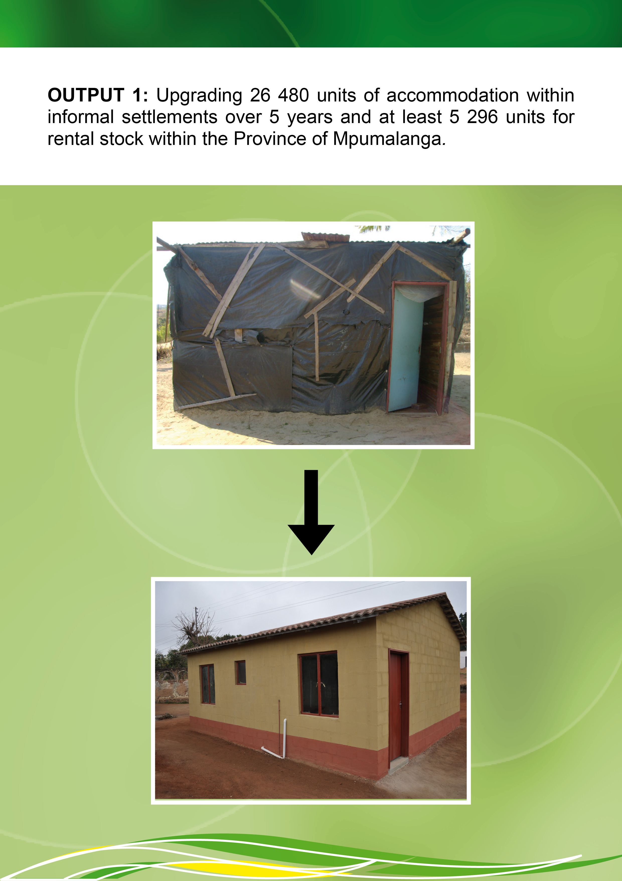

OUTPUT 1: Upgrading 26 480 units of accommodation within informal settlements over 5 years and at least 5 296 units for rental stock within the Province of Mpumalanga.
The province has at least 139 informal settlements that require upgrading, accrediting qualifying municipalities to enhance human settlements development. There is a need to conduct a land audit that identifies informal settlements in the province and link these to the land release programme to address the issues of eradication of informal settlements.
Furthermore there is also a need to ensure that settlements are integrated and sustainable. There should be an established project committees and formalised the committees. Improve the integrated planning process to ensure integration between the IDP and APP.
The department should source capital grant funding for the development of rental stock and to align the Social Housing Institutions to be in line with the Social Housing Act. These institutions should be capacitated to ensure that they are self sufficient and sustainable.
The identification of suitable land for rental stock to facilitate for the release of funds to social housing institutions, this would facilitate for the promotion of inner city rejuvenation /redevelopment through the acquisition of suitable buildings to be converted into residential units.
Together with Department of Cooperative Governance and Traditional Affairs, support the development of sustainable human settlements through proper spatial development framework (town planning and coordination of the integrated service delivery of services around human settlements developments).The department should facilitate tenure upgrading and explore alternative sources of funding.
The department through its rural housing programme will interact with Department of Agriculture, Rural Development and Land Administration to contribute towards Outcome 7, Output 2.

IMPLEMENTATION PLAN
Output 1 (5 yrs targets) | Indicator/ Measure | Baseline | 2009/2010 Targets |  | 2010/11Targets |  | 2011/12 Targets |  | 2012/13 /Targets |  | 2013/14 Targets |  | Key Partners | Contribution from key partners
Output 1 (5 yrs targets) | Indicator/ Measure | Baseline | Units | Budget  R’000 | Units | Budget  R’000 | Units | Budget  R’000 | Units | Budget  R’000 | Units | Budget  R’000 | Key Partners | Contribution from key partners
Upgrading of 26 480 informal settlements units | Number of informal settlements upgraded | 808 units completed out of 1886 units planned for 2009/10 | 1 886 units | 131,629 | 3 404 informal settlements units | 204 ,240 | 6 833 units | 397, 779 | 5 060 units | 321,377 | 9 096 units | 865,313 | Municipalities  Housing  Associations  Sector Departments  National Department of Human Settlements (National Upgrading Support Programme)  National Home Builders Registration Council  Banking Sectors  Social Housing Foundations | Provision of by-laws  Provision of financial support
Upgrading of 26 480 informal settlements units | Number of servicing of sites |  | 1 756 units | 33, 181 887 | 6 067 units | 140, 685 | 5 857 units | 497, 797 | 4 579 units | 120, 322 | 6 067 units | 140, 685 |  | Provision of by-laws  Provision of financial support
Upgrading of 26 480 informal settlements units | Number of rental housing stock | 900 units | 950 units | 70, 000 | 245 units | 8 400 | 2 770 units | 196250 | 2 924 units | 278,300 | 720 units | 55,000 |  | Provision of by-laws  Provision of financial support

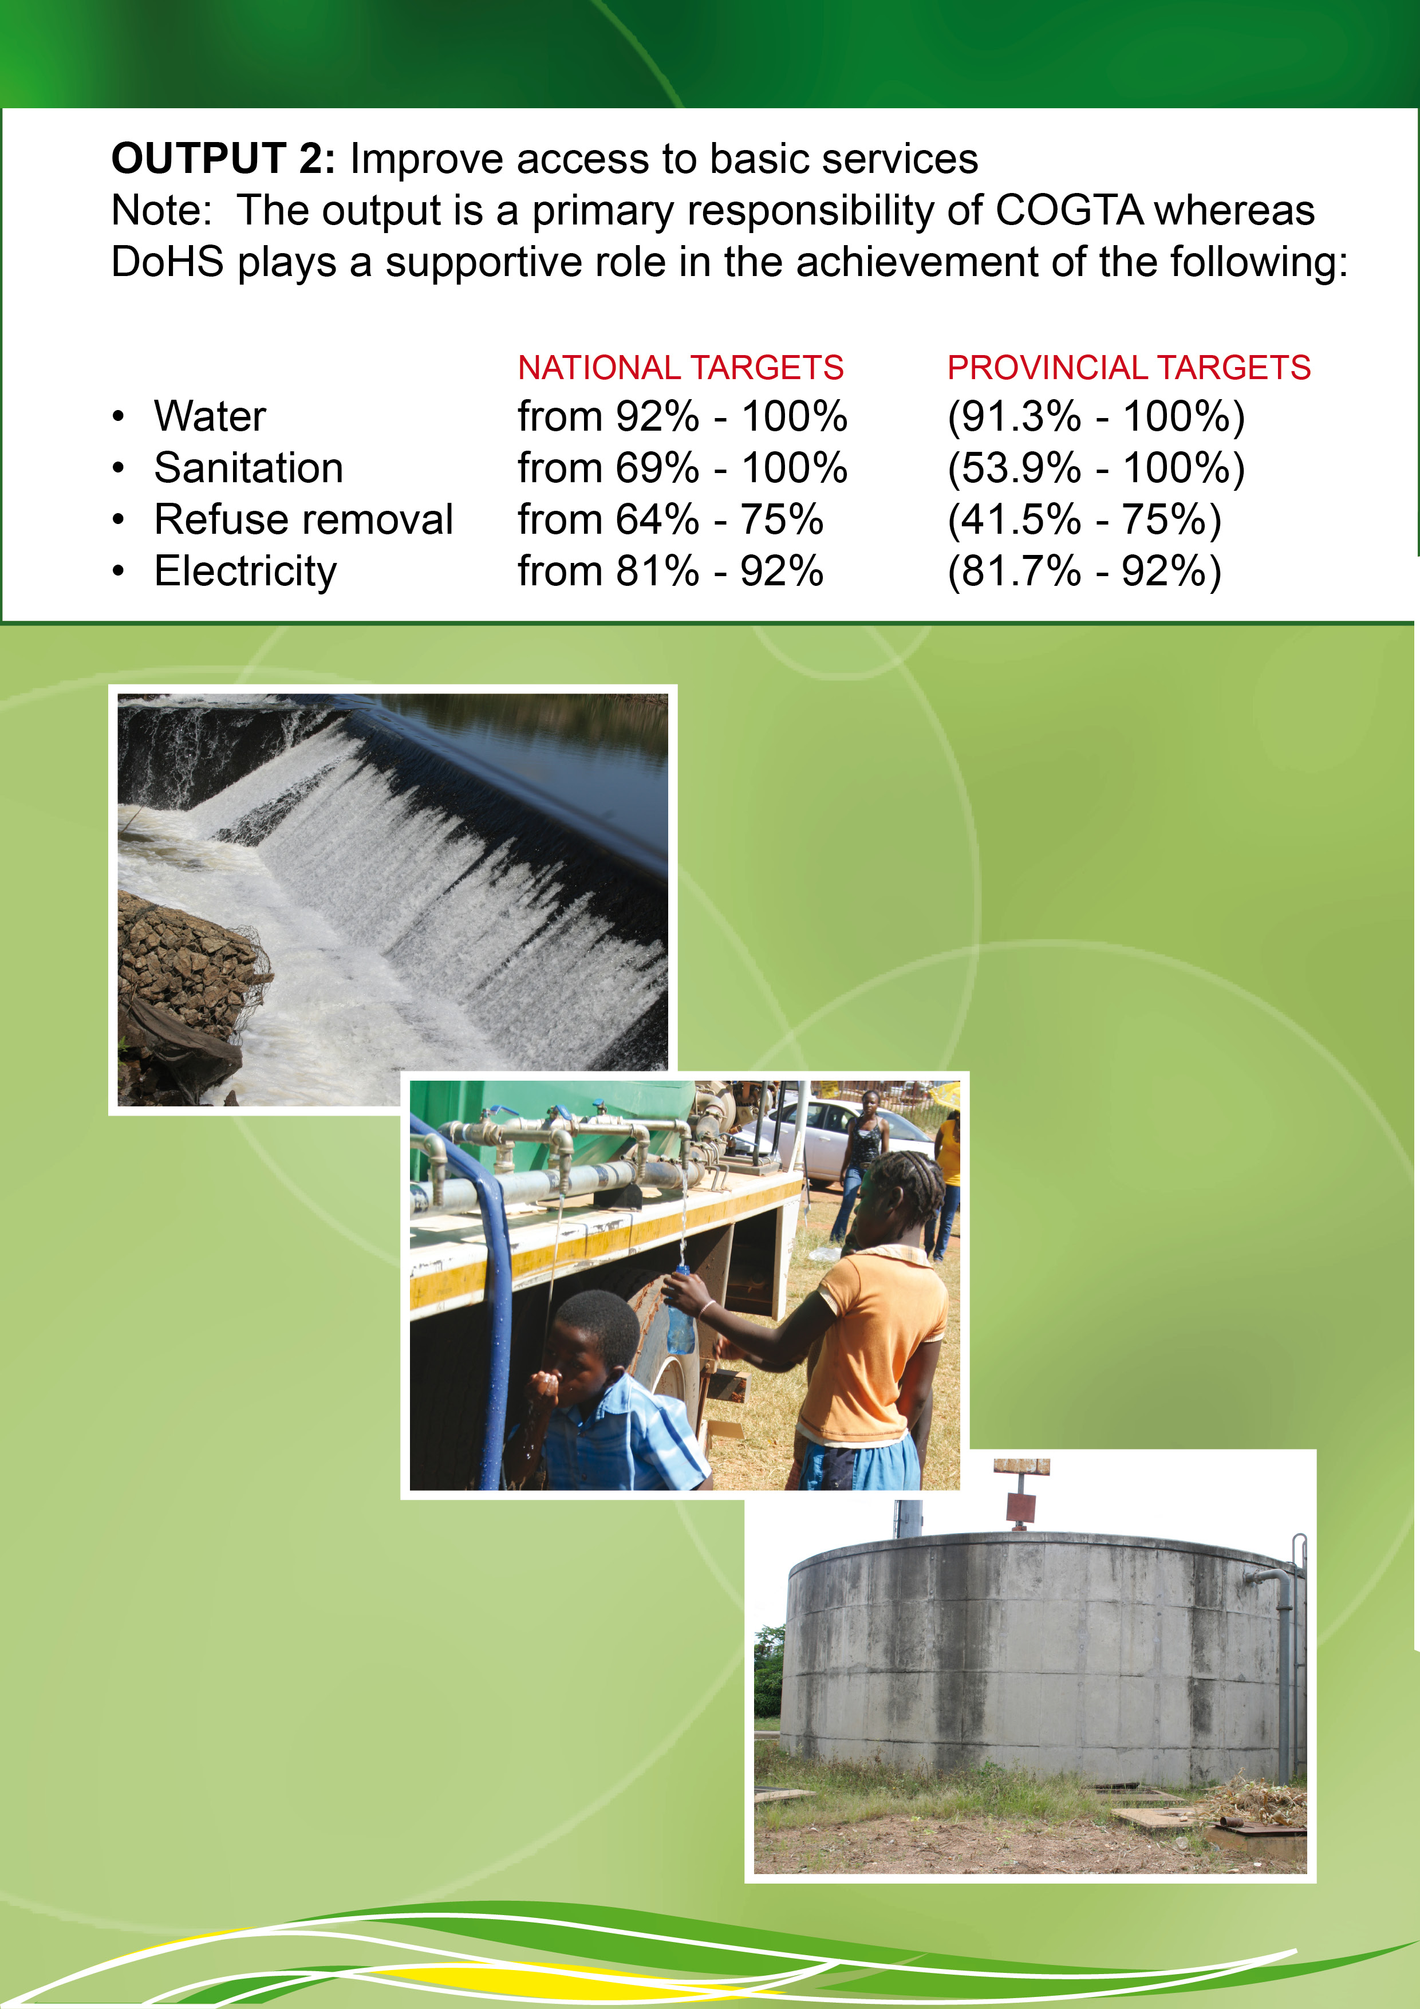
OUTPUT 2: Improve access to basic services

The department should support the alignment of provincial infrastructure grants towards the development of integrated human settlements projects and contribute to the eradication of service delivery backlogs through the delivery of human settlements (target of 26 480 households). The department should facilitate the development of provincial bulk water and sanitation plan, coordinate and report the backlog figures to the Department of Cooperative Governance and Traditional Affairs as a single window of reporting.
The department should support Department of Cooperative Governance and Traditional Affairs in the development of a plan to support municipalities to increase household access to services and the eradication of water backlogs in critical rural areas through implementation of small projects and the support of the provision of emergency water supply to critical areas.
The Department will be a key stakeholder on the technical implementation forum on Outcome 9, output 2.

IMPLEMENTATION PLAN

Output 2  (5 yrs Targets) | Indicator/ Measure | Baseline | 2009/10 Targets |  | 2010/11 Targets |  | 2011/12 Targets |  | 2012/13 Targets |  | 2013/14 Targets |  | Key Partners | Contribution from key partners
Output 2  (5 yrs Targets) | Indicator/ Measure | Baseline | Services | Budget  R’000 | Services | Budget  R’000 | Services | Budget  R’000 | Services | Budget  R’000 | Services | Budget  R’000 | Key Partners | Contribution from key partners
Improve access to basic services | Number of settlements benefiting from eradication of water services backlogs | No baseline as functions were recently transferred to DoHS | - | - | Water service backlog eradicated on 80 informal settlements | 21,000 | As per approved projects in Provincial Bulk Water plan | As per approved budget | As per approved projects in Provincial Bulk Water plan | As per approved budget | As per approved projects in Provincial Bulk Water plan | As per approved budget | Provincial Department Cooperative Governance and Traditional Affairs  Department of Water Affairs  Municipalities  Department of Economic Development, Environment and Tourism  Office of the Premier  Eskom | Provision of bulk infrastructure
 |  |  |  |  | 20 water tankers procured
 |  |  |  |  | Jo-Jo tanks provided to communities per
 |  |  |  |  | Interventions to mitigate direct impact sewerage spillages as per demand

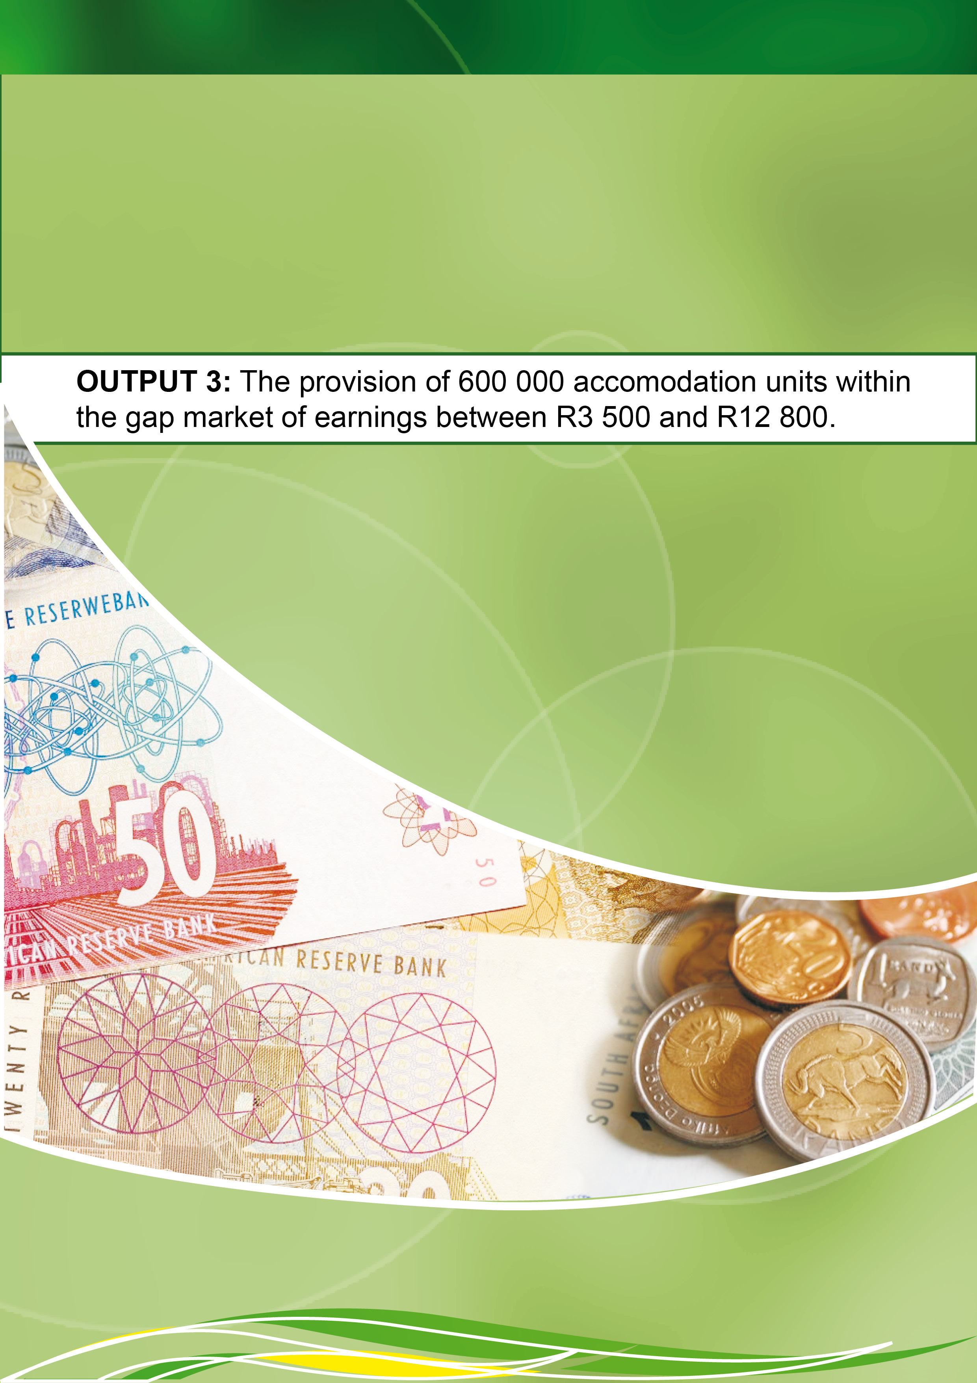
OUTPUT 3: The provision of 600 000 accommodation units within the gap market of earnings between R 3 500 and R 12 800
A guarantee scheme to provide underwriting and first loss cover to commercial lenders for housing finance must be established and private sectors should be involved for the development of sustainable human settlements and the facilitation of servicing of sites and selling thereof. There should be participation in policy formulation on the guaranteed scheme and establishment of housing bank. An intensified consumer awareness on the various products should be made available within this market with the involvement of MEGA through DEDET to increase access to housing loans.

IMPLEMENTATION PLAN
Output 3  (5 yrs Targets) | Indicator/ Measure | Baseline | 2009/10 Targets |  | 2010/11 Targets |  | 2011/12 Targets |  | 2012/13 Targets |  | 2013/14 Targets |  | Key Partners | Contribution from key partners
Output 3  (5 yrs Targets) | Indicator/ Measure | Baseline | Units | Budgets  R’000 | Units | Budget  R’000 | Units | Budget  R’000 | Units | Budget  R’000 | Units | Budget  R’000 | Key Partners | Contribution from key partners
The provision of accommodation units within a gap market earning between R3 500 and R12 800 | Number of units provided within a gap market earning between R3 500 and R12 800 | _  NB: The output is addressed as Individual Housing Subsidies | - | - | 480 units | 40,320 | - | - | - | - | - | - | Banking Institutions  Mpumalanga Economic Growth Agency  Department of Economic Development Environment and Tourism  Department of Trade and Industry (National Credit Regulator)  National Department of Human Settlements  National and Provincial Treasury  Office of the Presidency  Provincial Department of Agriculture and Rural Development  Rural Development and Land Reform  Municipalities  NHBRC  Provincial Department of Cooperative Governance and Traditional Affairs | Provision of financial support
 | Number of Serviced Sites | - | - | - | 6 067 units | 140,685 | 5 857 units | 497,797 | 4 579 units | 120, 322 | 6 067 units | 140,685 |  | Provision of financial support
 | Number of rental housing stock | 900 units | 950 units | 70, 000 | 245 units | 8 400 | 2 770 units | 196,250 | 2 924 units | 278,300 | 720 units | 55,000 |  | Provision of financial support

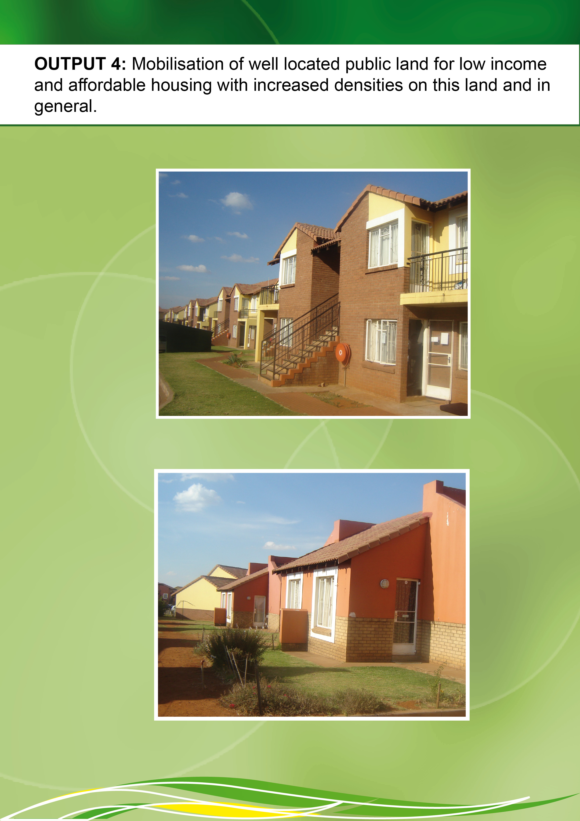
OUTPUT 4: Mobilisation of well located public land for low income and affordable housing with increased densities on this land and in general
There should be consultation with municipalities, departments and public owned entities to determine the minimum amount of land to be released in order to meet the target (target 26 480). An assessment of suitable land for human settlements and facilitate for the release of public land for human settlements development. The land must be examined for suitability of achieving optimisation through densification and implementation and support thereof with Outcome 9. Properties which have been transferred to Housing institutions should be identified for the development of rental stock. Affordable rental accommodation refers to rental in formal structures that meet the conditions of rental housing legislations, is affordable to households earning R3500 and R12 800 and subsidised by government. These types of units must subscribe quality, typology and environmental standards.

IMPLEMENTATION PLAN
Output 4  (5 yrs Targets) | Indicator/ Measure | Baseline | 2009/10 Targets |  | 2010/11 Targets |  | 2011/12 Targets |  | 2012/13 Targets |  | 2013/14 Targets |  | Key Partners | Contribution from key partners
Output 4  (5 yrs Targets) | Indicator/ Measure | Baseline | No. of Portions | Budgets  R’000 | No. of Portions | Budget  R’000 | No. of Portions | Budget  R’000 | No. of Portions | Budget  R’000 | No. of Portions | Budget  R’000 | Key Partners | Contribution from key partners
Mobilisation of well located public land for low income and affordable housing with increased densities on this land and in general | Number of portions of land acquired for low income and affordable housing | - | - | - | 1 portion of land | 27,000 | - | - | - | - | - | - | Department of Public Works, Roads and Transport  Municipalities  National Department of Rural Development and Land Reform  Department of Agriculture, Rural Development and Land Administration  Provincial Department of Cooperative Governance and Traditional Affairs (Traditional Leaders)  Public Entities  National Department of Human Settlements  National Department of Public Works  National Defence  Communal Property Associations | Provision of land for human settlements

6. SIGNATORIES

The following are the signatories to this Delivery Agreement and hence commit themselves towards achieving the desired outcomes and outputs of this document.

SIGNATURE: _______________________ DATE: __________________2010
MR. M.S.A. MASANGO, MPL, MEMBER OF EXECUTIVE COUNCIL FOR HUMAN SETTLEMENTS

SIGNATURE: _______________________ DATE: __________________2010
MRS. Y.N. PHOSA, MPL, MEMBER OF EXECUTIVE COUNCIL FOR FINANCE

SIGNATURE: _______________________ DATE: __________________2010
MR. M.N. MOKOENA, MPL, MEMBER OF EXECUTIVE COUNCIL FOR ECONOMIC DEVELOPMENT, ENVIRONMENT AND TOURISM

SIGNATURE: _______________________ DATE: _________________2010
MR. M.B. MASUKU, MPL, MEMBER OF EXECUTIVE COUNCIL FOR COOPERATIVE GOVERNANCE AND TRADITIONAL AFFAIRS

SIGNATURE: _______________________ DATE: _________________2010
MRS. M.R. MHAULE, MPL, MEMBER OF EXECUTIVE COUNCIL FOR EDUCATION

SIGNATURE: _______________________ DATE: ________________2010
MRS. D.G. MAHLANGU, MPL, MEMBER OF EXECUTIVE COUNCIL FOR HEALTH AND SOCIAL DEVELOPMENT

SIGNATURE: _______________________ DATE: ________________2010
MRS. K.C. MASHEGO-DLAMINI, MPL, MEMBER OF EXECUTIVE COUNCIL FOR AGRICULTURE, RURAL DEVELOPMENT AND LAND ADMINISTRATION

SIGNATURE: _______________________ DATE: ________________2010
DR. R.C. MKASI, MPL, MEMBER OF EXECUTIVE COUNCIL FOR PUBLIC WORKS, ROADS AND TRANSPORT

SIGNATURE: _______________________ DATE: ________________2010
MRS. M.N.S. MANANA, MPL, MEMBER OF EXECUTIVE COUNCIL FOR CULTURE, SPORTS AND RECREATION

SIGNATURE: _______________________ DATE: ________________2010
MR. V.R. SHONGWE, MPL, MEMBER OF EXECUTIVE COUNCIL FOR SAFETY, SECURITY AND LIAISON

MUNICIPALITY STAKEHOLDERS

SIGNATURE: _______________________ DATE: _______________2010
CLR. A. GAMEDE, EXECUTIVE MAYOR OF GERT SIBANDE DISTRICT MUNICIPALITY

SIGNATURE: _______________________ DATE: _________2010
CLR. S. DLAMINI, EXECUTIVE MAYOR OF ALBERT LUTHULI LOCAL MUNICIPALITY

SIGNATURE: _______________________ DATE: _________2010
CLR. B.C. VILAKAZI, EXECUTIVE MAYOR OF MSUKWALIGWA LOCAL MUNICIPALITY

SIGNATURE: _______________________ DATE: _________2010
CLR. K. MPUNGOSE, EXECUTIVE MAYOR OF MKHONDO LOCAL MUNICIPALITY
SIGNATURE: _______________________ DATE: _________2010
CLR. S.N. NXUMALO, EXECUTIVE MAYOR OF PIXELY KA SEME LOCAL MUNICIPALITY

SIGNATURE: _______________________ DATE: _________2010
CLR.J.Q. RADEBE-KHUMALO, EXECUTIVE MAYOR OF LEKWA LOCAL MUNICIPALITY

SIGNATURE: _______________________ DATE: _________2010
CLR. L. TSOTETSI, EXECUTIVE AYOR OF DIPALESENG LOCAL MUNICIPALITY

SIGNATURE: _______________________ DATE: _________2010
CLR. S. NKOSI, EXECUTIVE AYOR OF GOVAN MBEKI LOCAL MUNICIPALITY

SIGNATURE: _______________________ DATE: _________2010
CLR. S.K. MASHILO, EXECUTIVE MAYOR OF NKANGALA DISTRICT MUNICIPALITY

SIGNATURE: _______________________ DATE: _________2010
CLR. J. RAPATSA, EXECUTIVE MAYOR OF VICTOR KHANYE LOCAL MUNICIPALITY

SIGNATURE: _______________________ DATE: _________2010
CLR. L. MALATJIE, EXECUTIVE MAYOR OF EMALAHLENI LOCAL MUNICIPALITY

SIGNATURE: _______________________ DATE: _________2010
CLR. M. MAHLANGU, EXECUTIVE MAYOR OF STEVE TSHWETE LOCAL MUNICIPALITY

SIGNATURE: _______________________ DATE: _________2010
CLR. L. MOHLALA, EXECUTIVE MAYOR OF EMAKHAZENI LOCAL MUNICIPALITY

SIGNATURE: _______________________ DATE: _________2010
CLR. V.V. NKOSI, EXECUTIVE MAYOR OF THEMBISILE HANI LOCAL MUNICIPALITY

SIGNATURE: _______________________ DATE: _________2010
CLR. I.M. MASOMBUKA, EXECUTIVE MAYOR OF DR.J.S. MOROKA LOCAL MUNICIPALITY

SIGNATURE: _______________________ DATE: _________2010
CLR. K.C. MKHONTO, EXECUTIVE MAYOR OF EHLANZENI DISTRICT MUNICIPALITY

SIGNATURE: _______________________ DATE: _________2010
CLR. T. MOKALE, EXECUTIVE MAYOR OF THABA CHWEU LOCAL MUNICIPALITY

SIGNATURE: _______________________ DATE: _________2010
CLR. L. CHIWAYO, EXECUTIVE MAYOR OF MBOMBELA LOCAL MUNICIPALITY

SIGNATURE: _______________________ DATE: _________2010
CLR. R. LUKHELE, EXECUTIVE MAYOR OF UMJINDI LOCAL MUNICIPALITY

SIGNATURE: _______________________ DATE: _________2010
CLR. J.M. MAVUSO, EXECUTIVE MAYOR OF NKOMAZI LOCAL MUNICIPALITY

SIGNATURE: _______________________ DATE: _________2010
CLR. M. MOREMA, EXECUTIVE AYOR OF BUSHUBUCKRIDGE LOCAL MUNICIPALITY

